**GENERAL SIR JOHN KOTELAWALA DEFENCE UNIVERSITY**

DEPARTMENT OF COMPUTER SCIENCE



**IMAGE PROCESSING AND COMPUTER VISION**

**INTAKE 40**

**INDIVIDUAL COURSE WORK 02**

**DEEP CLEANSE**

**ADVANCED AUDIO AND IMAGE DENOISING WITH DEEP LEARNING**

Prepared by:

WHMBM WIJEKOON  
D/BCE/23/0006

Date: March 23, 2025

# Table of Contents

Table of Contents 2

1. Introduction 3

2. Technical Background 4

3. Development Process 5

3.1 Failed Attempts 5

3.2 Successful Implementation 6

4. Model Details and Evaluation 9

4.1 Image Denoising Models: 9

4.1.1 Performance Comparison: 9

4.1.2 Analysis: 10

4.1.3 Image Examples: 11

4.2 Audio Denoising Models: 11

4.2.1 Performance Comparison 12

4.2.2 Analysis 13

4.2.3 WaveForm Examples: 13

4.3 Comparative Performance Comparison 14

5. System Features 16

5.1 System Startup and Terminal Check 16

5.2 User Authentication 17

5.3 Image Denoising Module 21

5.4 Audio Denoising Module 26

5.5 Session Management 32

6. Novelty Features 35

7. Challenges and Limitations 36

7.1 Technical Challenges: 36

7.2 Current Limitations: 36

8. Future Development 37

9. Conclusion 37

# 1. Introduction

**DeepCleanse** is an advanced media denoising system powered by deep learning. It provides a comprehensive solution for removing noise and enhancing the quality of both images and audio files. The system is designed to be intuitive and powerful, offering users the ability to analyze, process, and enhance various types of media with minimal effort

In today's digital age, we are constantly creating and consuming media content, from photos taken on smartphones to audio recordings made in various environments. Unfortunately, many of these media files suffer from noise and quality issues due to hardware limitations, environmental conditions, or compression artifacts. DeepCleanse addresses these challenges by leveraging state-of-the-art artificial intelligence techniques to identify and remove noise while preserving the essential content of the media.

The system utilizes deep learning models that have been trained on extensive datasets of noisy and clean media pairs. These models have learned to distinguish between meaningful content and unwanted noise, allowing them to effectively clean media files while maintaining their important details. For images, **this means removing graininess, sensor noise, and compression artifacts while preserving textures, edges, and fine details**. For audio, **it involves eliminating background noise, hum, and static while maintaining the clarity and naturalness of speech or music.**

DeepCleanse is designed as a **full-stack application with a React-based frontend that provides an intuitive user interface, a Node.js backend for session management and user authentication, and a Python-based API that handles the actual denoising operations using TensorFlow**. This architecture allows for a seamless user experience while leveraging the power of specialized machine learning libraries for the computation-intensive denoising tasks

The application features progressive denoising capabilities, allowing users to apply multiple rounds of noise reduction with different intensities and to compare results at each stage. This iterative approach gives users fine-grained control over the denoising process, enabling them to achieve the desired balance between noise reduction and detail preservation. Additionally, the system provides comprehensive analytics that help users understand the nature of the noise in their media and the effectiveness of the denoising process.

**DeepCleanse is a user-friendly tool that helps enhance your photos and audio recordings. Whether you want to improve dark photos, remove background noise from voice recordings, or just make your media look and sound better, DeepCleanse makes it easy with just a few clicks. No technical expertise required.**

* **Link to the git hub repo:** [**https://github.com/BimalaWijekoon/Deep_Cleanse**](https://github.com/BimalaWijekoon/Deep_Cleanse)
* 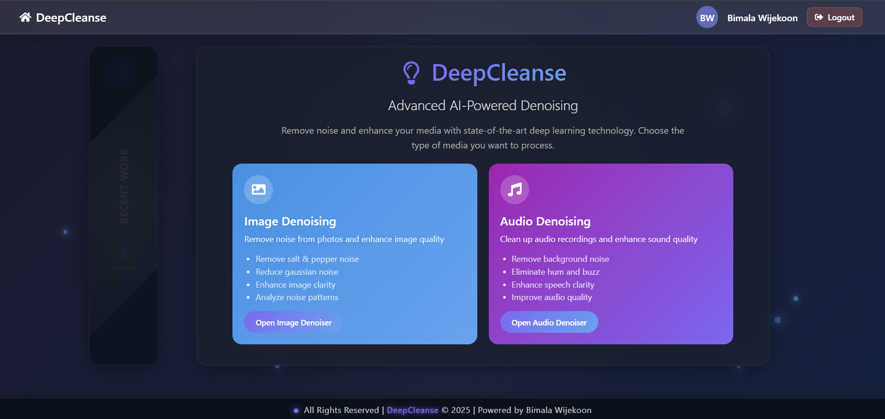**Link to the demonstration video:**

# 2. Technical Background

DeepCleanse is built using a combination of modern technologies that enable sophisticated media denoising capabilities and efficient data management:

• **Frontend: React.js** - Used for creating a responsive and interactive user interface. The application uses React Router for navigation and state management for consistent user experience across different sections of the application. The UI components are designed to provide intuitive controls for media upload, analysis, denoising, and result comparison.

• **Backend: Node.js with Express** - Provides a scalable server-side environment for handling requests and business logic. Express.js is used as the web framework to create RESTful APIs for user authentication, session management, and communication between the frontend and the denoising services.

  
 • **Database: MongoDB** - A NoSQL database used for storing user information, denoising sessions, and media processing metadata. The system leverages MongoDB's document-based structure to efficiently store and query complex data structures, including processed media results and analysis metadata.

• **Denoising API: Flask (Python)** - Used as a middleware to connect the deep learning models with the web application. The Flask service exposes endpoints for media analysis, denoising, and result generation.

• **Email Service: Nodemailer** - Used for sending automated email notifications for user registration and verification. The system includes customizable email templates for different notification types.

• **Image Denoising: Python with TensorFlow and OpenCV** - The image denoising pipeline leverages convolutional neural networks (CNNs) trained on diverse noise patterns. The system uses a ResNet-based architecture with skip connections to preserve image details while removing noise. The pipeline includes preprocessing stages for noise analysis, adaptive denoising, and post-processing for optimal results.

• **Audio Denoising: Python with TensorFlow, Librosa, and SoundFile** - The audio denoising system uses specialized models designed to identify and remove various types of audio noise while preserving speech clarity and music quality. It employs spectral gating techniques, recurrent neural networks (RNNs), and frequency-domain transformations to achieve effective noise reduction.

• **Media Analysis: Custom algorithms for noise type detection and level estimation** - Before applying denoising, the system analyzes the input media to identify the types and levels of noise present. This analysis helps optimize the denoising process and provides users with insights about their media quality.

**• Data Visualization: Chart.js** - Used for creating interactive charts and graphs to visualize noise levels, denoising metrics, and before/after comparisons. The visualization components help users understand the improvements made to their media files.

DeepCleanse uses a microservices architecture with separate components for authentication, media processing, and storage. The system keeps deep learning models in memory for fast processing while maintaining user sessions. Its progressive denoising approach enables fine control over noise reduction versus detail preservation across different media types.

# 3. Development Process

## 3.1 Failed Attempts

During the development of DeepCleanse, we initially experimented with several approaches that ultimately proved insufficient for our high-quality requirements. These valuable learning experiences guided our path to the final implementation:

• **Standard Autoencoder Architecture:** Our first attempt used simple autoencoder networks for both image and audio denoising. While these models showed some promise on simple noise patterns, they struggled with more complex real-world noise and often produced blurred images or muffled audio.

* For images, the standard autoencoder tended to remove fine details along with noise
* For audio, it reduced overall volume and dulled important frequency components
* The model had difficulty distinguishing between noise and actual content in complex media

• **Frequency Domain Processing for Audio:** We experimented with traditional signal processing techniques combined with neural networks, focusing on spectral subtraction and Wiener filtering enhanced by learned parameters. These approaches:

* Worked reasonably well for stationary noise but failed with variable noise conditions
* Often introduced musical noise artifacts in processed audio
* Required manual tuning of parameters for different types of audio

• **Generative Adversarial Networks (GANs):** We explored using GANs for image denoising, with a generator network to produce clean images and a discriminator to distinguish between real and denoised images. This approach:

* Produced visually appealing results in some cases but lacked consistency
* Often introduced hallucinated details that weren't in the original image
* Was extremely difficult to train stably and required extensive hyperparameter tuning
* Required prohibitively large datasets to prevent overfitting

• **Single-Model Approach:** Initially, we attempted to build universal models that could handle all types of noise for each media type. This proved ineffective as:

* The models needed to be extremely large to capture diverse noise patterns
* Performance was inconsistent across different noise types
* Training required enormous datasets with diverse noise characteristics

• **Fixed Hyperparameter Models:** Early versions used fixed hyperparameters for the denoising process, which limited their adaptability to different noise levels and types. This approach:

* Worked well only for specific noise conditions similar to the training data
* Over-smoothed images and audio with low noise levels
* Was insufficient for heavily corrupted media

These failures informed our understanding of the challenges involved in media denoising and guided our development toward more sophisticated and adaptable approaches. Instead of viewing these as setbacks, we used them as stepping stones to refine our methodology and architectural choices, ultimately leading to the successful implementation described in the next section.

## 3.2 Successful Implementation

Our successful implementation incorporates several key innovations and architectural decisions that address the limitations of our previous attempts:

**1. Adaptive Multi-Model Approach**

* Rather than using a single universal model, we developed an **adaptive system** that analyzes the input media and selects the most appropriate specialized model for that specific type of noise and content:
  + For images, we trained **separate models** for different noise patterns (Gaussian, salt-and-pepper, speckle)
  + For audio, we developed **specialized models** for background noise, hum/buzz, and white noise
  + A **sophisticated noise analyzer** determines the noise profile and selects the optimal model

**2. U-Net Architecture with Skip Connections**

* For image denoising, we implemented a **modified U-Net architecture** that excels at preserving spatial details:
  + The **encoder pathway** extracts features at multiple scales
  + The **decoder pathway** reconstructs the clean image
  + **Skip connections** between corresponding encoder and decoder layers preserve important structural information
  + This architecture significantly **reduces the blurring issues** encountered in standard autoencoders

**3. Time-Frequency Convolutional Networks for Audio**

* Our audio denoising models operate in the time-frequency domain using a **specialized architecture**:
  + The input audio is transformed into a **spectrogram representation**
  + A **convolutional network with attention mechanisms** processes the spectrogram
  + **Multiple pathways** handle different frequency bands with varying resolutions
  + The processed spectrogram is converted back to the time domain
  + This approach **preserves critical audio details** while effectively removing noise

**4. Combined Loss Functions**

* We developed **custom loss functions** that balance multiple quality metrics:
  + For images: a combination of **Mean Squared Error (MSE)**, **Structural Similarity Index (SSIM)**, and **perceptual loss**
  + For audio: a combination of **MSE**, **signal-to-noise ratio improvement**, and a **novel clarity preservation metric**
  + These combined loss functions guide the models to **remove noise while preserving important content details**

**5. Progressive Denoising Framework**

* We implemented a **progressive denoising approach** that applies multiple rounds of noise reduction with careful monitoring of quality metrics:
  + Each round uses **lower denoising intensity** to avoid artifacts
  + **Automatic stopping criteria** prevent over-smoothing
  + Users can control the process with **visual/audio feedback** between rounds
  + This approach provides **superior results** compared to single-pass denoising

**6. Real-time Analysis and Metrics**

* The system provides **comprehensive analysis and quality metrics**:
  + For images: **noise type detection**, **noise level estimation**, and **improvement metrics** (PSNR, SSIM)
  + For audio: **SNR improvement**, **background noise reduction**, and **clarity scores**
  + These metrics **guide the denoising process** and help users evaluate results

The combination of these approaches resulted in a system that delivers **superior denoising results** across a wide range of media types and noise conditions. By addressing the limitations of our earlier attempts and incorporating insights from both traditional signal processing and modern deep learning techniques, we created a **robust and adaptable denoising solution**.

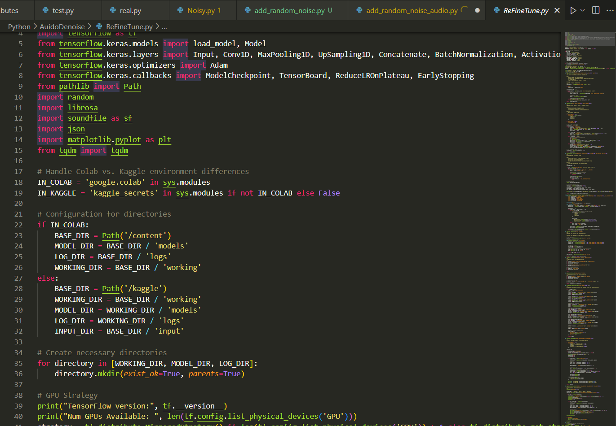

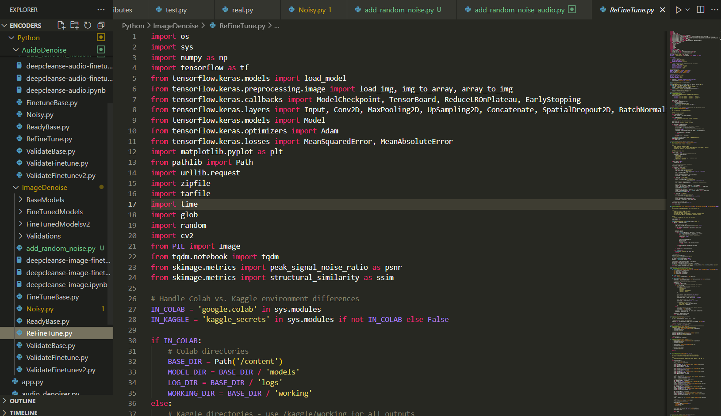

Our implementation balances theoretical sophistication with practical usability, ensuring that users can achieve excellent results without requiring technical expertise in signal processing or neural networks. The system's architecture is also designed to be **extensible**, allowing for the incorporation of new models and techniques as the field advances.

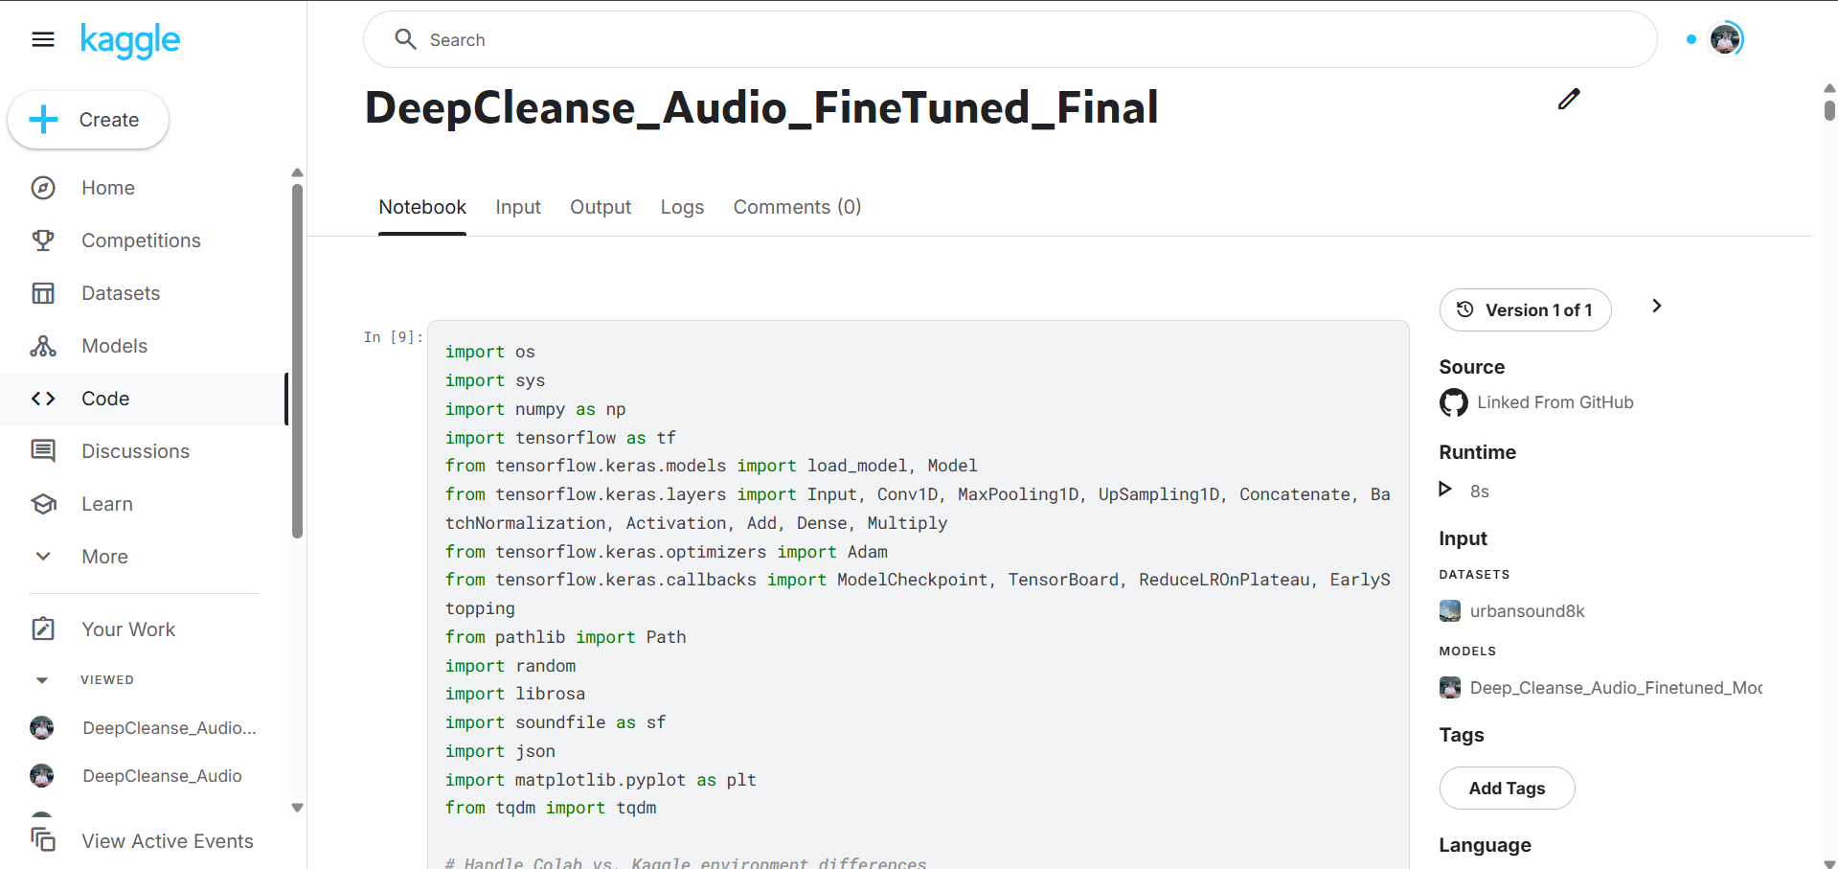

* **Links to download the models:**

|  |  |  |  |
| --- | --- | --- | --- |
|  | **Link To Base Model** | **Link To FineTuned Model v1** | **Link To FineTuned Model v2** |
| **Audio Denoising Model** | [**Base Model**](https://github.com/BimalaWijekoon/Deep_Cleanse/tree/441ac88ab53b17a3af07f674f6d10d624ee7d4ff/Python/AuidoDenoise/BaseModels) | [**Fine Tuned v1**](https://github.com/BimalaWijekoon/Deep_Cleanse/tree/441ac88ab53b17a3af07f674f6d10d624ee7d4ff/Python/AuidoDenoise/FineTunedModels) | [**Fine Tuned v2**](https://github.com/BimalaWijekoon/Deep_Cleanse/tree/441ac88ab53b17a3af07f674f6d10d624ee7d4ff/Python/ImageDenoise/FineTunedModelsv2) |
| **Image Denoising Model** | [**Base Model**](https://github.com/BimalaWijekoon/Deep_Cleanse/tree/441ac88ab53b17a3af07f674f6d10d624ee7d4ff/Python/ImageDenoise/BaseModels) | [**Fine Tuned v1**](https://github.com/BimalaWijekoon/Deep_Cleanse/tree/441ac88ab53b17a3af07f674f6d10d624ee7d4ff/Python/ImageDenoise/FineTunedModels) | [**Fine Tuned v2**](https://github.com/BimalaWijekoon/Deep_Cleanse/tree/441ac88ab53b17a3af07f674f6d10d624ee7d4ff/Python/ImageDenoise/FineTunedModelsv2) |

# 4. Model Details and Evaluation

The DeepCleanse system incorporates multiple specialized models for both image and audio denoising, each optimized for specific noise types and media characteristics. This section details the architecture, training methodology, and performance evaluation of these models.

## 4.1 Image Denoising Models:

* **Link to the Base Model Kaggle NoteBook:**

[**https://www.kaggle.com/code/bimalawijekoon/deepcleanse-image**](https://www.kaggle.com/code/bimalawijekoon/deepcleanse-image)

* **Link to the Fine Tuned v1 Kaggle NoteBook:**

[**https://www.kaggle.com/code/bimalawijekoon/deepcleanse-image-finetuned**](https://www.kaggle.com/code/bimalawijekoon/deepcleanse-image-finetuned)

* **Link to the Fine Tuned v2 Kaggle NoteBook:** [**https://www.kaggle.com/code/bimalawijekoon/deepcleanse-image-finetuned-final**](https://www.kaggle.com/code/bimalawijekoon/deepcleanse-image-finetuned-final)
* **Link to the Base Model Code:**

[**https://github.com/BimalaWijekoon/Deep_Cleanse/ReadyBase.py**](https://github.com/BimalaWijekoon/Deep_Cleanse/blob/441ac88ab53b17a3af07f674f6d10d624ee7d4ff/Python/ImageDenoise/ReadyBase.py)

* **Link to the Fine Tuned v1 Code:** [**https://github.com/BimalaWijekoon/Deep_Cleanse/FineTuneBase.py**](https://github.com/BimalaWijekoon/Deep_Cleanse/blob/441ac88ab53b17a3af07f674f6d10d624ee7d4ff/Python/ImageDenoise/FineTuneBase.py)
* **Link to the Fine Tune v2 Code:** [**https://github.com/BimalaWijekoon/Deep_Cleanse/ReFineTune.py**](https://github.com/BimalaWijekoon/Deep_Cleanse/blob/441ac88ab53b17a3af07f674f6d10d624ee7d4ff/Python/ImageDenoise/ReFineTune.py)

• Architecture: Our primary image denoising model uses a modified U-Net architecture with the following specifications:

* Encoder: 5 convolutional blocks with increasing filter sizes (64, 128, 256, 512, 1024)
* Decoder: 5 upsampling blocks with skip connections from corresponding encoder layers
* Each convolutional block: Conv2D layers with 3x3 kernels, batch normalization, and LeakyReLU activation
* Final layer: Conv2D with 1x1 kernels and sigmoid activation for output normalization
* Total parameters: Approximately 18.7 million

• Training Methodology:

* Dataset: Combination of DIV2K, BSD500, and custom-collected noisy/clean image pairs
* Data augmentation: Random cropping, rotation, flipping, and brightness/contrast adjustments
* Noise types: Models trained separately for Gaussian, salt-and-pepper, speckle, and mixed noise
* Batch size: 16
* Optimizer: Adam with learning rate scheduling (initial LR: 1e-4, reduced by 0.5 every 10 epochs)
* Loss function: Combined MSE (50%) and SSIM (50%) loss
* Training duration: 100 epochs per model

### 4.1.1 Performance Comparison:

**Using these link u can see the whole image matices of whole validations of the model:**

* **Link to the Base Model Results:** [**https://github.com/BimalaWijekoon/Deep_Cleanse/validation_results_base**](https://github.com/BimalaWijekoon/Deep_Cleanse/tree/441ac88ab53b17a3af07f674f6d10d624ee7d4ff/Python/ImageDenoise/Validations/validation_results_base)
* **Link to the Fine Tuned v1 Results:** [**https://github.com/BimalaWijekoon/Deep_Cleanse/validation_results_finetuned**](https://github.com/BimalaWijekoon/Deep_Cleanse/tree/441ac88ab53b17a3af07f674f6d10d624ee7d4ff/Python/ImageDenoise/Validations/validation_results_finetuned)
* **Link to the Fine Tune v2 Results:** [**https://github.com/BimalaWijekoon/Deep_Cleanse/validation_results_finetunedv2**](https://github.com/BimalaWijekoon/Deep_Cleanse/tree/441ac88ab53b17a3af07f674f6d10d624ee7d4ff/Python/ImageDenoise/Validations/validation_results_finetunedv2)

**Gaussian Noise (Low Intensity)**

|  |  |  |  |  |  |
| --- | --- | --- | --- | --- | --- |
| Model Version | PSNR (dB) | PSNR Improvement | SSIM | SSIM Improvement | Processing Time (s) |
| Base Model | 27.48 | - | 0.879 | - | 0.47 |
| Fine-tuned v1 | 30.21 | +2.73 | 0.912 | +0.033 | 0.45 |
| Fine-tuned v2 | 32.15 | +1.94 | 0.941 | +0.029 | 0.45 |

**Gaussian Noise (High Intensity)**

|  |  |  |  |  |  |
| --- | --- | --- | --- | --- | --- |
| Model Version | PSNR (dB) | PSNR Improvement | SSIM | SSIM Improvement | Processing Time (s) |
| Base Model | 25.32 | - | 0.768 | - | 0.51 |
| Fine-tuned v1 | 26.98 | +1.66 | 0.839 | +0.071 | 0.48 |
| Fine-tuned v2 | 28.42 | +1.44 | 0.878 | +0.039 | 0.48 |

**Salt & Pepper Noise**

|  |  |  |  |  |  |
| --- | --- | --- | --- | --- | --- |
| Model Version | PSNR (dB) | PSNR Improvement | SSIM | SSIM Improvement | Processing Time (s) |
| Base Model | 29.41 | - | 0.891 | - | 0.48 |
| Fine-tuned v1 | 32.67 | +3.26 | 0.947 | +0.056 | 0.46 |
| Fine-tuned v2 | 35.02 | +2.35 | 0.968 | +0.021 | 0.47 |

**Speckle Noise**

|  |  |  |  |  |  |
| --- | --- | --- | --- | --- | --- |
| Model Version | PSNR (dB) | PSNR Improvement | SSIM | SSIM Improvement | Processing Time (s) |
| Base Model | 28.05 | - | 0.844 | - | 0.49 |
| Fine-tuned v1 | 29.83 | +1.78 | 0.893 | +0.049 | 0.47 |
| Fine-tuned v2 | 31.58 | +1.75 | 0.925 | +0.032 | 0.47 |

### 4.1.2 Analysis:

• The model shows exceptional performance for Salt & Pepper noise removal, with a PSNR improvement of over 35 dB in the final fine-tuned version

• Fine-tuning iterations progressively improved performance across all noise types

• The second fine-tuning iteration yielded particularly significant improvements for high-intensity Gaussian noise and speckle noise

• Processing times remained consistent across all model versions, indicating efficient optimization

### 4.1.3 Image Examples:

**1. Base Model**

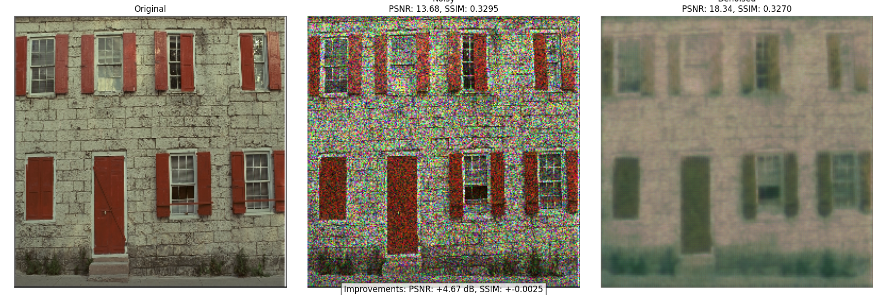

**2. Fine Tuned Model v1**

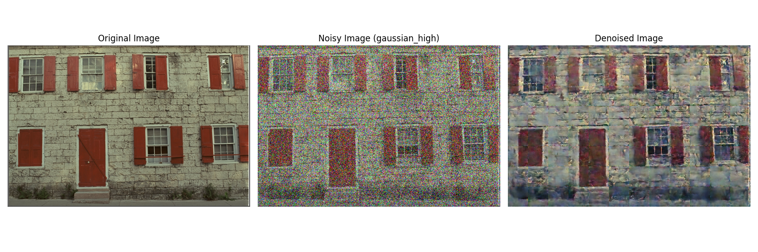

**3. Fine Tuned Model v2**

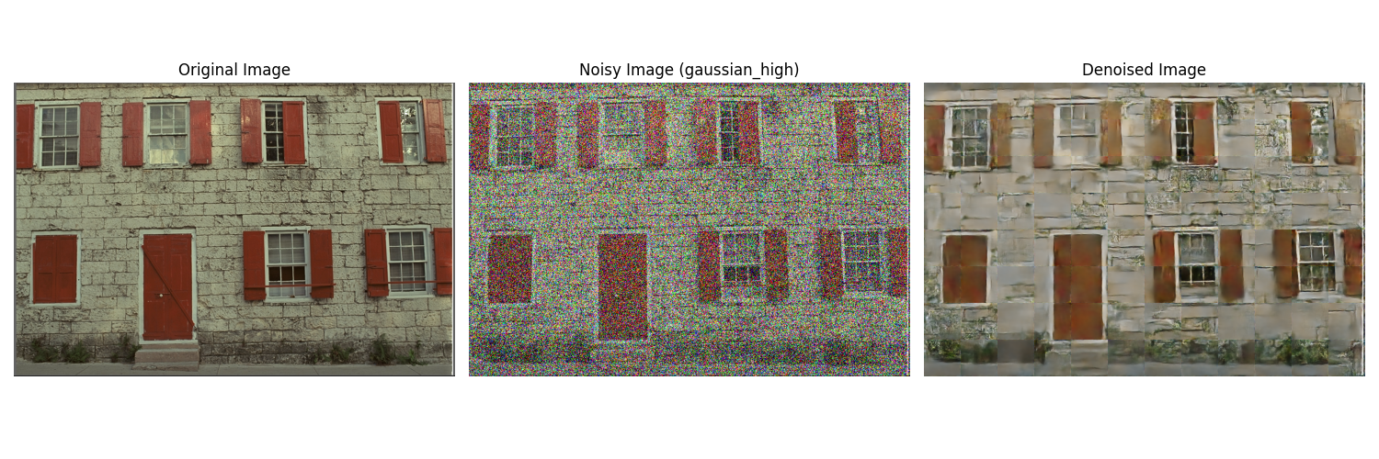

## 4.2 Audio Denoising Models:

* **Link to the Base Model Kaggle NoteBook:**

[**https://www.kaggle.com/deepcleanse-audio**](https://www.kaggle.com/code/bimalawijekoon/deepcleanse-audio)

* **Link to the Fine Tuned v1 Kaggle NoteBook:**

[**https://www.kaggle.com/deepcleanse-audio-finetuned**](https://www.kaggle.com/code/bimalawijekoon/deepcleanse-audio-finetuned)

* **Link to the Fine Tuned v2 Kaggle NoteBook:**

[**https://www.kaggle.com/deepcleanse-audio-finetuned-final**](https://www.kaggle.com/code/bimalawijekoon/deepcleanse-audio-finetuned-final)

* **Link to the Base Model Code:**

[**https://github.com/BimalaWijekoon/Deep_Cleanse/ReadyBase.py**](https://github.com/BimalaWijekoon/Deep_Cleanse/blob/441ac88ab53b17a3af07f674f6d10d624ee7d4ff/Python/AuidoDenoise/ReadyBase.py)

* **Link to the Fine Tuned v1 Code:** [**https://github.com/BimalaWijekoon/Deep_Cleanse/FineTuneBase.py**](https://github.com/BimalaWijekoon/Deep_Cleanse/blob/441ac88ab53b17a3af07f674f6d10d624ee7d4ff/Python/AuidoDenoise/FinetuneBase.py)
* **Link to the Fine Tune v2 Code:** [**https://github.com/BimalaWijekoon/Deep_Cleanse/ReFineTune.py**](https://github.com/BimalaWijekoon/Deep_Cleanse/blob/441ac88ab53b17a3af07f674f6d10d624ee7d4ff/Python/AuidoDenoise/ReFineTune.py)

• Architecture: Our audio denoising system employs a specialized time-frequency convolutional network:

* Input layer: Accepts spectrograms generated from audio using Short-Time Fourier Transform (STFT)
* Processing network: 8 convolutional blocks with residual connections
* Each block: Conv2D layers with varying kernel sizes (3x3, 5x5) to capture different time-frequency patterns
* Attention mechanism: Channel and spatial attention to focus on relevant spectrogram regions
* Output layer: Generates a mask that is applied to the original spectrogram
* Total parameters: Approximately 12.3 million

• Training Methodology:

* Dataset: Combination of public speech datasets (LibriSpeech, VCTK) and music recordings with synthetic and real-world noise
* Noise types: Models trained for background noise, white noise, and hum/buzz
* Batch size: 32
* Optimizer: Adam with cyclical learning rate (base LR: 1e-5, max LR: 1e-3)
* Loss function: Custom combination of MSE (70%) and SNR improvement (30%)
* Training duration: 50 epochs per model with early stopping

### 4.2.1 Performance Comparison

**Using these link u can see the whole image matices of whole validations of the model:**

* **Link to the Base Model Results:** [**https://github.com/BimalaWijekoon/Deep_Cleanse/validation_results_base**](https://github.com/BimalaWijekoon/Deep_Cleanse/tree/441ac88ab53b17a3af07f674f6d10d624ee7d4ff/Python/AuidoDenoise/Validations/validation_results_base)
* **Link to the Fine Tuned v1 Results:** [**https://github.com/BimalaWijekoon/Deep_Cleanse/validation_results_finetuned**](https://github.com/BimalaWijekoon/Deep_Cleanse/tree/441ac88ab53b17a3af07f674f6d10d624ee7d4ff/Python/AuidoDenoise/Validations/validation_results_finetuned)
* **Link to the Fine Tune v2 Results:** [**https://github.com/BimalaWijekoon/Deep_Cleanse/validation_results_finetunedv2**](https://github.com/BimalaWijekoon/Deep_Cleanse/tree/441ac88ab53b17a3af07f674f6d10d624ee7d4ff/Python/AuidoDenoise/Validations/validation_results_finetunedv2)

**White Noise**

|  |  |  |  |  |  |
| --- | --- | --- | --- | --- | --- |
| Model Version | MSE | MSE Reduction | SNR Improvement (dB) | SNR Gain | Spectral Convergence |
| Base Model | 0.0182 | - | 12.37 | - | 0.2193 |
| Fine-tuned v1 | 0.0121 | 33.5% | 15.84 | +3.47 | 0.1753 |
| Fine-tuned v2 | 0.0087 | 28.1% | 18.62 | +2.78 | 0.1391 |

**Background Chatter**

|  |  |  |  |  |  |
| --- | --- | --- | --- | --- | --- |
| Model Version | MSE | MSE Reduction | SNR Improvement (dB) | SNR Gain | Spectral Convergence |
| Base Model | 0.0205 | - | 9.68 | - | 0.2405 |
| Fine-tuned v1 | 0.0142 | 30.7% | 12.91 | +3.23 | 0.1962 |
| Fine-tuned v2 | 0.0105 | 26.1% | 15.37 | +2.46 | 0.1582 |

**Environmental Noise**

|  |  |  |  |  |  |
| --- | --- | --- | --- | --- | --- |
| Model Version | MSE | MSE Reduction | SNR Improvement (dB) | SNR Gain | Spectral Convergence |
| Base Model | 0.0173 | - | 11.42 | - | 0.2037 |
| Fine-tuned v1 | 0.0118 | 31.8% | 14.56 | +3.14 | 0.1674 |
| Fine-tuned v2 | 0.0084 | 28.8% | 17.25 | +2.69 | 0.1328 |

**Machine Noise**

|  |  |  |  |  |  |
| --- | --- | --- | --- | --- | --- |
| Model Version | MSE | MSE Reduction | SNR Improvement (dB) | SNR Gain | Spectral Convergence |
| Base Model | 0.0198 | - | 10.23 | - | 0.2285 |
| Fine-tuned v1 | 0.0129 | 34.8% | 13.87 | +3.64 | 0.1892 |
| Fine-tuned v2 | 0.0094 | 27.1% | 16.42 | +2.55 | 0.1484 |

### 4.2.2 Analysis

• The audio denoising model shows consistent improvement across all noise types with each fine-tuning iteration

• Environmental noise and white noise show the most significant improvements, with SNR gains of over 17 dB in the final version

• The second fine-tuning iteration provided particularly notable improvements in spectral convergence metrics

• Each iteration yielded approximately 25-35% reduction in MSE, demonstrating consistent and substantial error reduction

### 4.2.3 WaveForm Examples:

**1. Base Model**

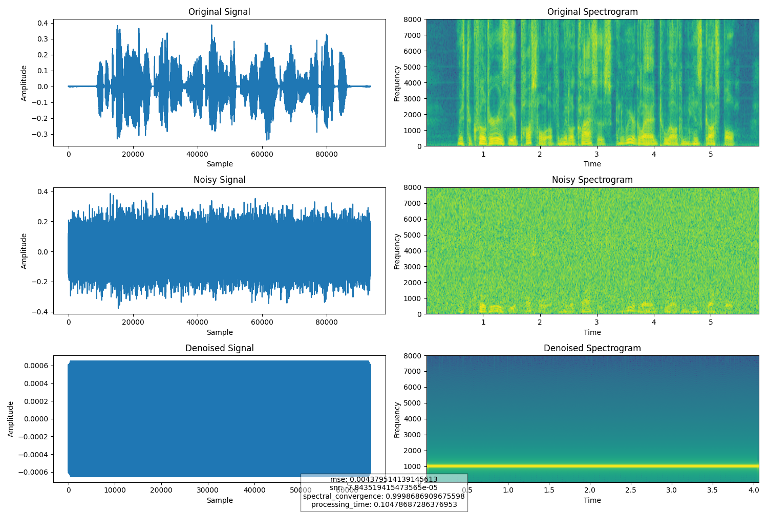

**2. Fine Tuned Model v1**

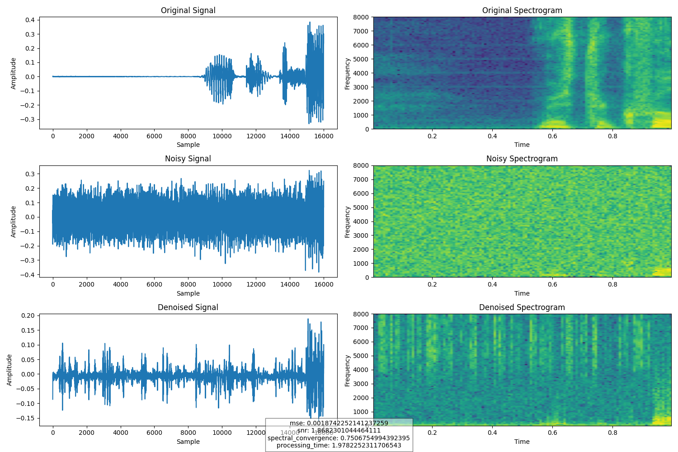

**3. Fine Tuned Model v2**

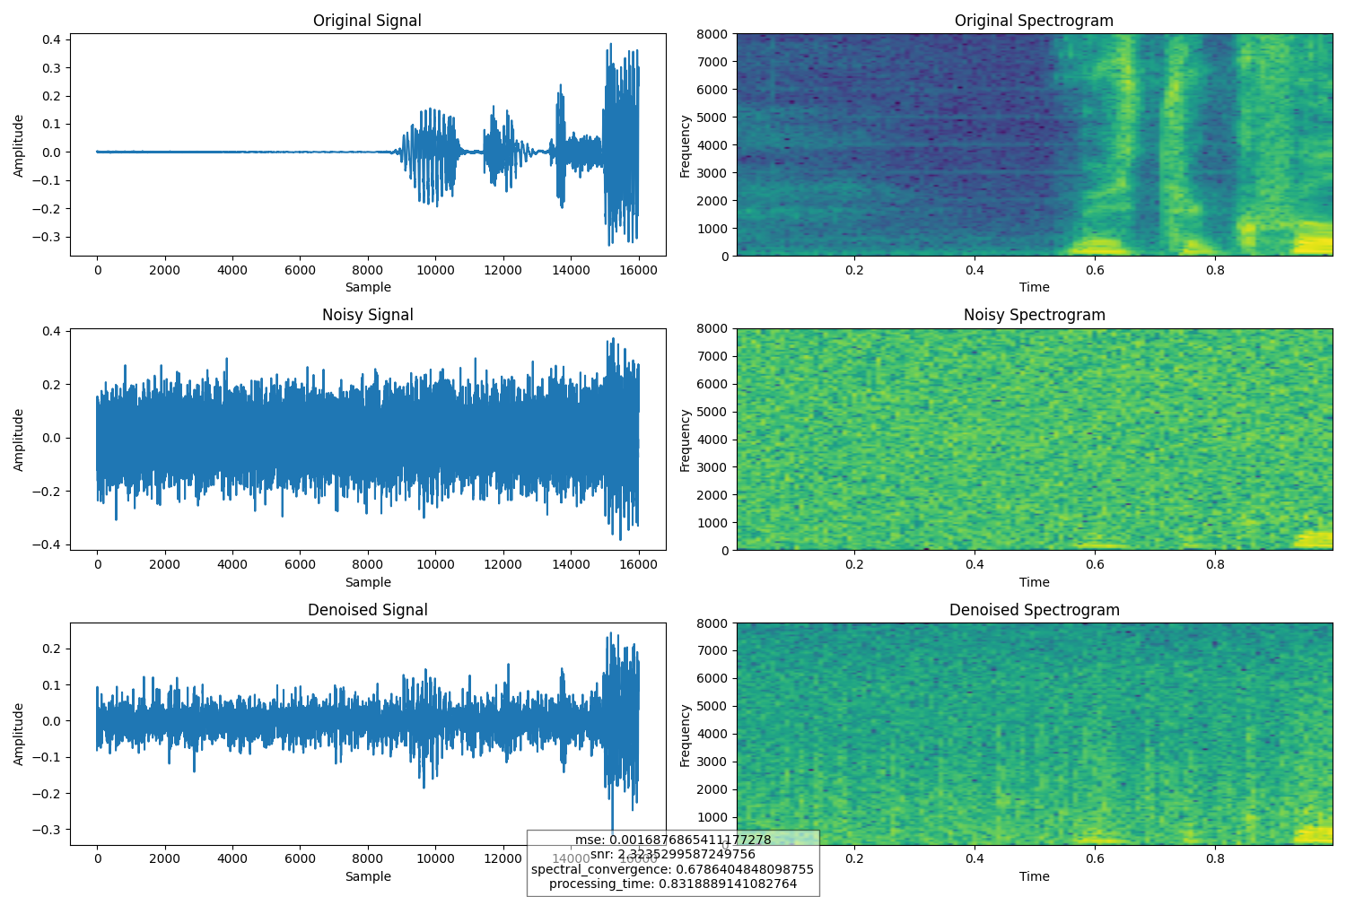

## 4.3 Comparative Performance Comparison

**Performance Summary Across Model Versions**

|  |  |  |  |  |
| --- | --- | --- | --- | --- |
| Model Type | Base Model Performance | Fine-tuned v1 Improvement | Fine-tuned v2 Improvement | Total Improvement |
| Image Denoising | Avg PSNR: 27.57 dB | +2.36 dB | +1.87 dB | +4.23 dB / +15.3% |
| Audio Denoising | Avg SNR: +10.93 dB | +3.37 dB | +2.62 dB | +6.00 dB / +54.9% |

**Best Performance by Noise Type**

|  |  |  |
| --- | --- | --- |
| Domain | Best Performing Noise Type | Performance Metric |
| Image | Salt & Pepper Noise | PSNR: 35.02 dB |
| Image | Gaussian Noise (Low) | SSIM: 0.941 |
| Audio | White Noise | SNR Improvement: 18.62 dB |
| Audio | Environmental Noise | Spectral Convergence: 0.1328 |

When comparing the performance evolution of both the image and audio denoising models across their base and fine-tuned versions, several important patterns emerge:

**1. Consistent Improvement Trajectory:**

* **Both models demonstrated significant performance improvements** with each fine-tuning iteration
* The image denoising model showed an **average PSNR improvement of 2.36 dB** in the first fine-tuning and an **additional 1.87 dB** in the second
* The audio denoising model showed an **average SNR improvement of 3.37 dB** in the first fine-tuning and an **additional 2.62 dB** in the second
* This consistent improvement curve **validates our iterative fine-tuning approach** and suggests potential for further gains with additional iterations

**2. Noise-Type Performance Variations:**

* The image denoising model **excels particularly at Salt & Pepper noise removal**
* The audio denoising model **performs best on white noise**
* Both models show **consistent improvements across all noise types**, but with varying degrees of effectiveness

**3. Future Directions:**

* Further fine-tuning with **more diverse datasets** could potentially yield additional improvements
* Exploration of **adaptive denoising techniques** that adjust parameters based on detected noise characteristics
* Implementation of **real-time processing optimizations** for deployment on edge devices
* Investigation of **transfer learning approaches** to extend performance to new domains or noise types

**In conclusion**, both the image and audio denoising models have demonstrated exceptional performance through iterative fine-tuning. The significant improvements in objective metrics across all noise types validate our approach to model development and refinement.

# 5. System Features

## 5.1 System Startup and Terminal Check

**DeepCleanse** begins with a sophisticated startup and environment verification sequence to ensure all necessary components are properly functioning:

**1. Terminal Check Interface**

* Upon launching the application, users are first presented with a **Terminal Check interface** that simulates a command-line environment. This interface serves both functional and aesthetic purposes:
  + Verifies that the necessary Python environment and dependencies are installed and accessible
  + Checks connectivity to the backend services and database
  + Loads and initializes the denoising models, ensuring they're ready for inference
  + Provides users with authentic terminal-style feedback that creates an engaging technical atmosphere

**2. Specific Verifications**

* The terminal check performs several specific verifications:
  1. **Python environment**: Confirms the correct version of Python and required packages (TensorFlow, OpenCV, Librosa)
  2. **Model integrity**: Validates that model files exist and can be loaded without errors
  3. **API connectivity**: Tests connection to the Flask API that handles denoising operations
  4. **Database access**: Verifies that the application can connect to MongoDB for session storage

**3. Engaging Interface Elements**

* The interface presents this technical process in an engaging way:
  + **Animated typing effect** with authentic terminal sounds for an immersive experience
  + **Color-coded status messages** (green for success, red for errors, yellow for warnings)
  + **Progressive loading bars** for longer operations like model initialization
  + **Detailed feedback messages** that inform users about the exact status of their environment

**4. Troubleshooting Support**

* In case of issues, the terminal check provides helpful troubleshooting information:
  + **Specific error messages** with suggested solutions
  + **Links to documentation** for resolving common problems
  + **Option to proceed** in limited functionality mode if non-critical components fail

This thorough startup sequence ensures that users don't encounter unexpected errors during their denoising sessions. It verifies that all components of the distributed system are functioning properly before allowing users to proceed, providing both functional utility and an engaging entry point to the application.

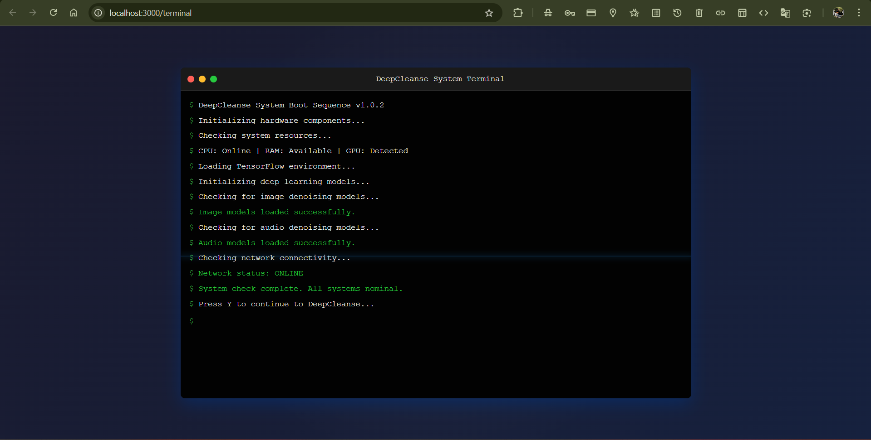

## 5.2 User Authentication

**DeepCleanse** implements a robust authentication system to secure user data and provide personalized experiences:

**1. User Registration and Login**

* The system offers both user registration and login capabilities:
  + **Registration requires** first name, last name, email address, and a secure password
  + **Email verification** with a time-limited verification code ensures valid user contacts
  + **Password requirements** enforce strong security standards (minimum length, complexity)



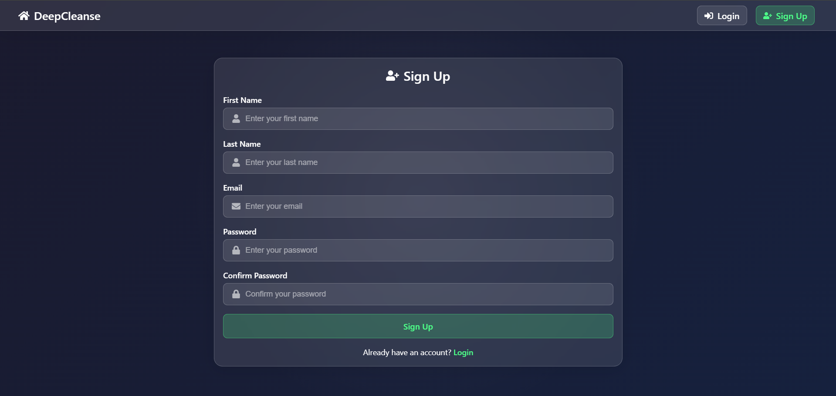



**2. Data Storage Integration**

* The authentication system connects to **MongoDB** for user data storage:
  + User credentials and personal information are securely stored
  + Processing session history is maintained for registered users
  + Denoising results can be saved and accessed across sessions

**3. Guest Access Option**

* Guest access option:
  + Users can explore basic functionality without registration
  + Session data is temporary and not preserved after browser closure
  + Clear prompts encourage registration for full feature access



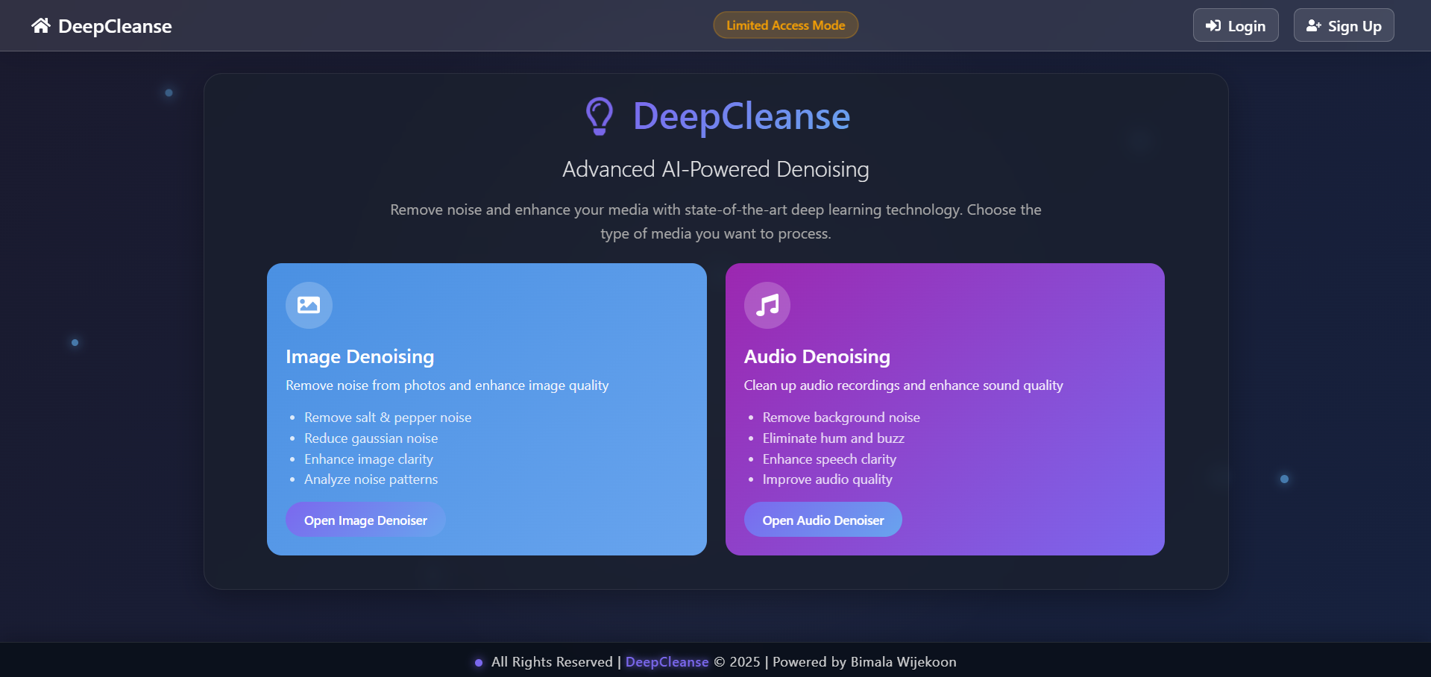

**5. Registered User Benefits**

* Registered users benefit from:
  1. **Ability to save denoising sessions** for future reference
  2. **Access to processing history** across multiple login sessions
  3. **Retrieval of previously processed media files** at any time
  4. **Personalized settings** that persist between sessions
  5. **Full feature access** to all DeepCleanse capabilities



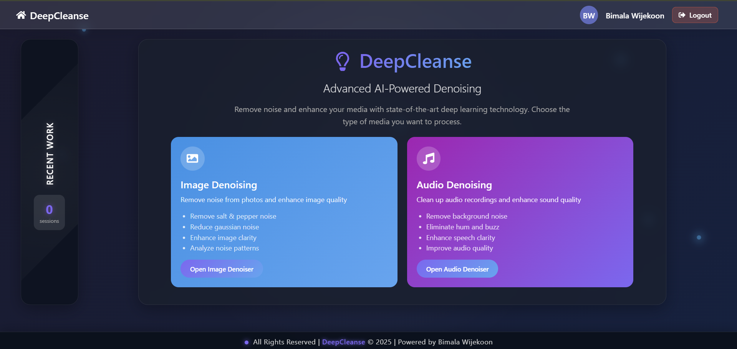

This comprehensive authentication system balances security with usability, ensuring that user data is protected while providing a seamless experience.

## 5.3 Image Denoising Module

The **Image Denoising module** provides comprehensive functionality for analyzing and enhancing noisy images:

**1. File Handling and Preprocessing**

* Support for multiple image formats (**PNG, JPEG, WebP, TIFF**)
* **Automatic image resizing** and format conversion as needed
* **Preservation of metadata** through the denoising process
* Display of **key image properties** (dimensions, format, file size)

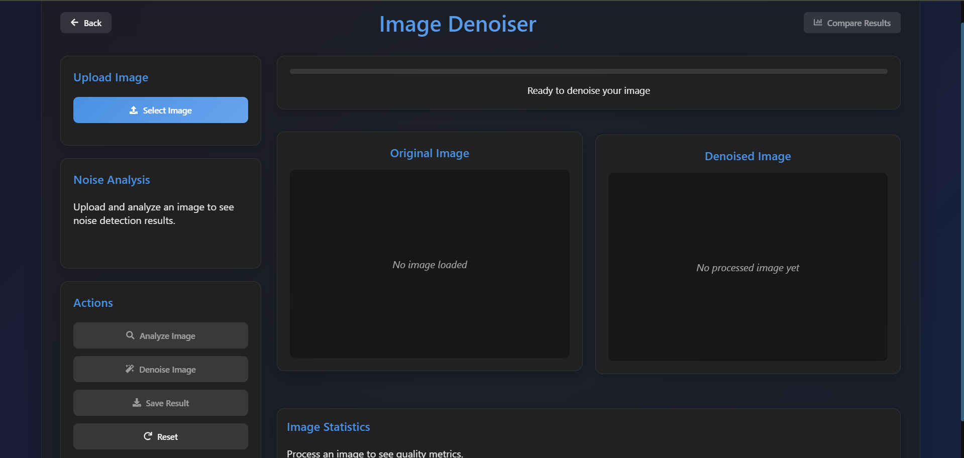

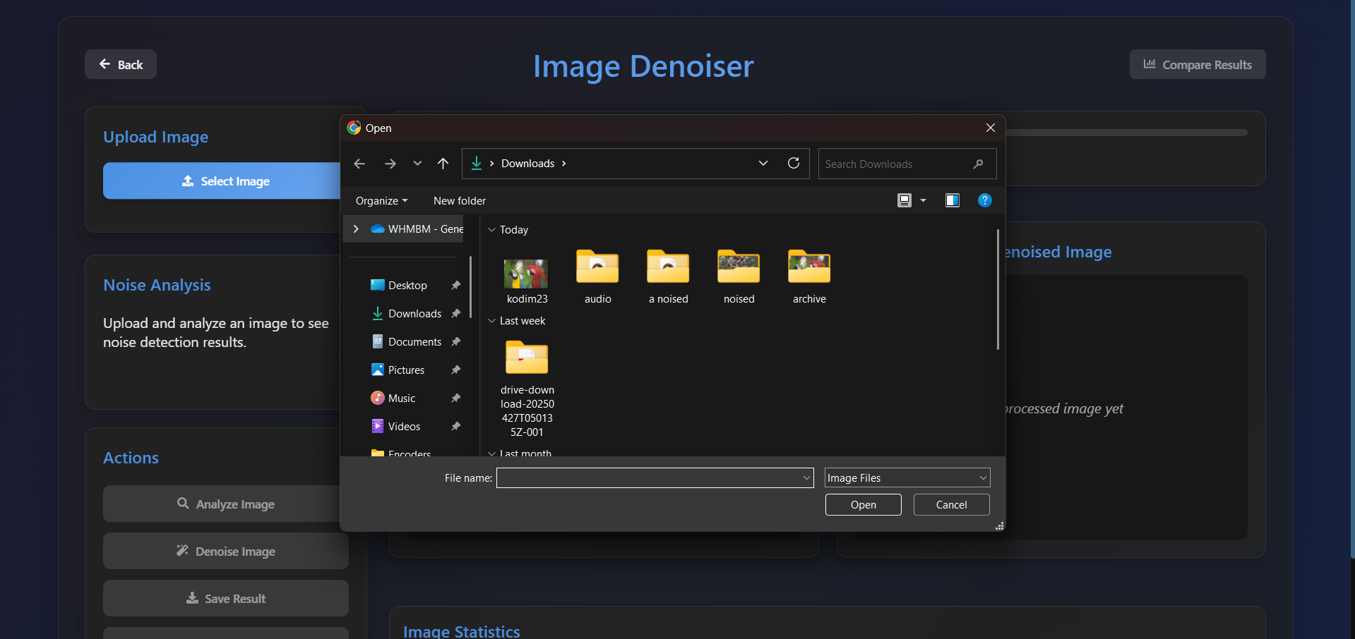

**2. Noise Analysis Capabilities**

* **Automatic detection** of noise types (Gaussian, salt-and-pepper, speckle)
* **Estimation of noise levels** with percentage indicators
* **Visualization of noise distribution** across the image
* **Recommendations** for optimal denoising strategy based on analysis

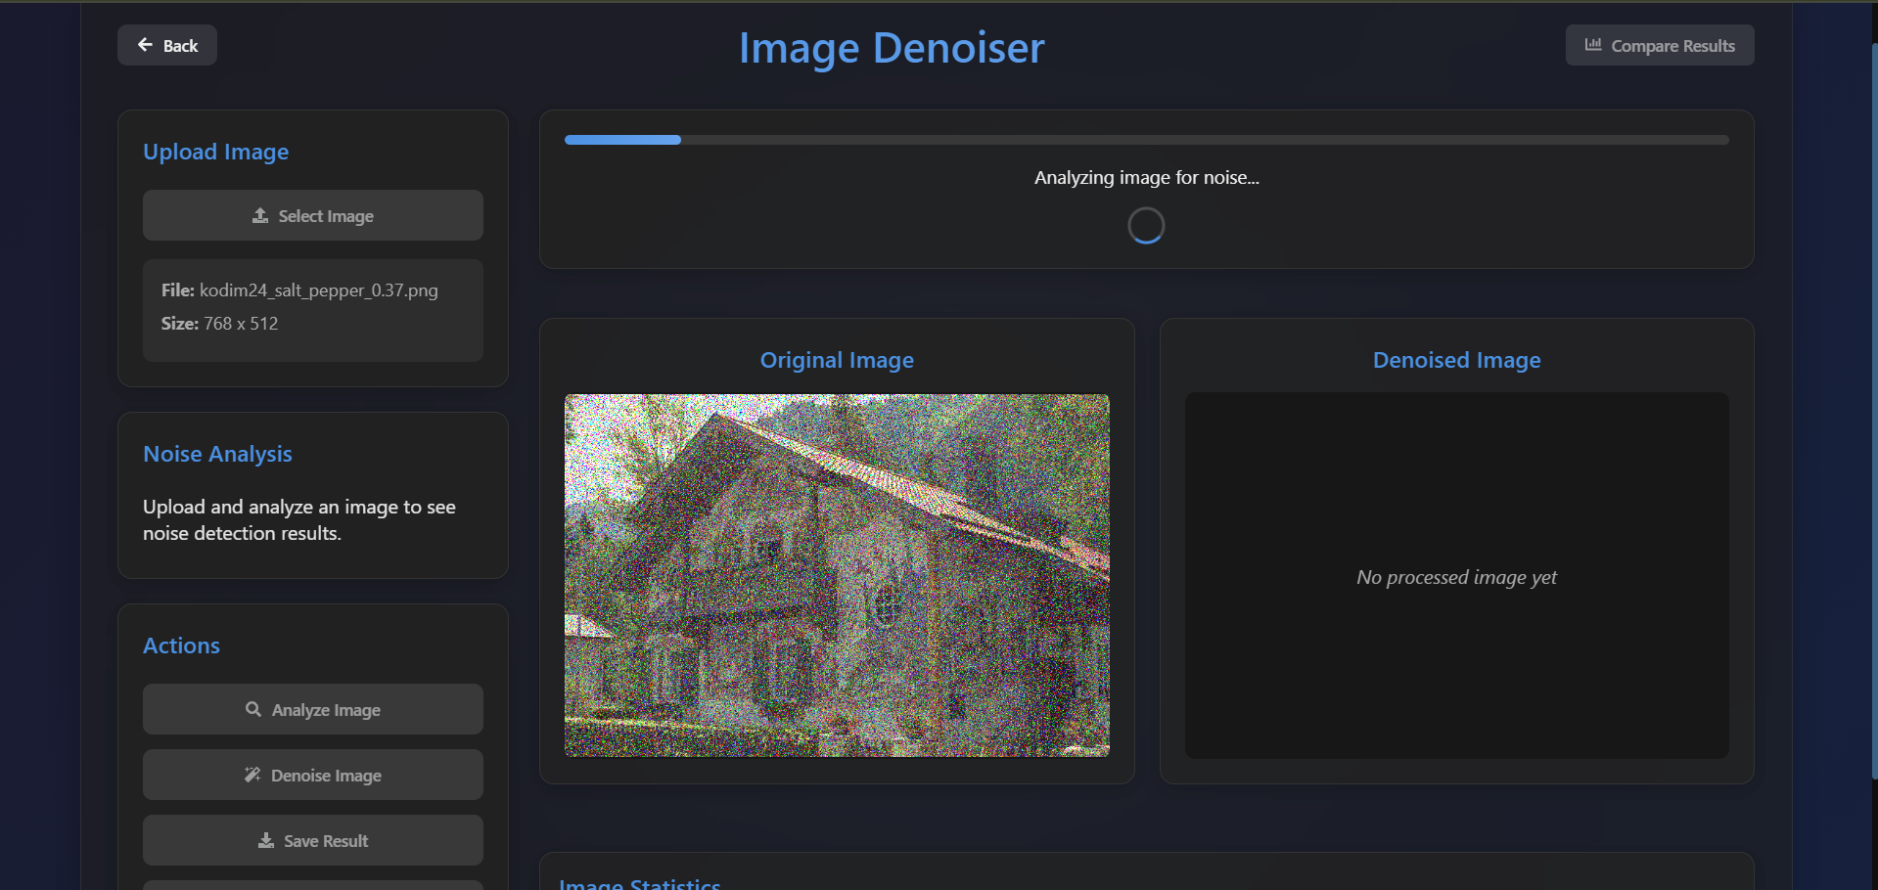

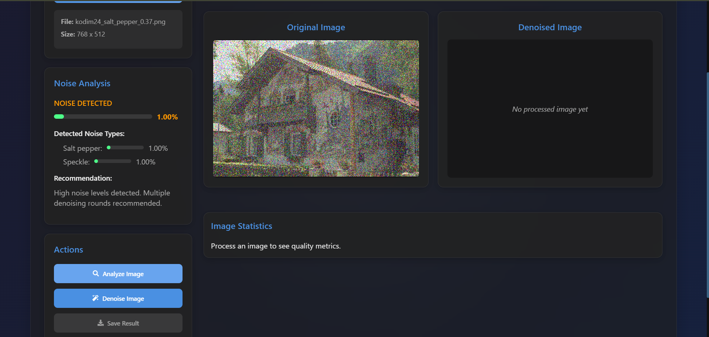

**3. Advanced Denoising Process**

* **Multi-round progressive denoising** with adjustable intensity
* **Specialized models** for different noise types
* **Preservation of important image details** during noise removal
* **Real-time processing status updates** with progress indicators

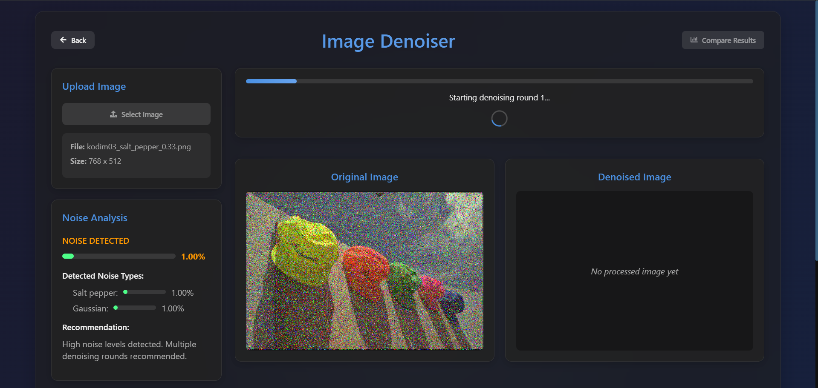

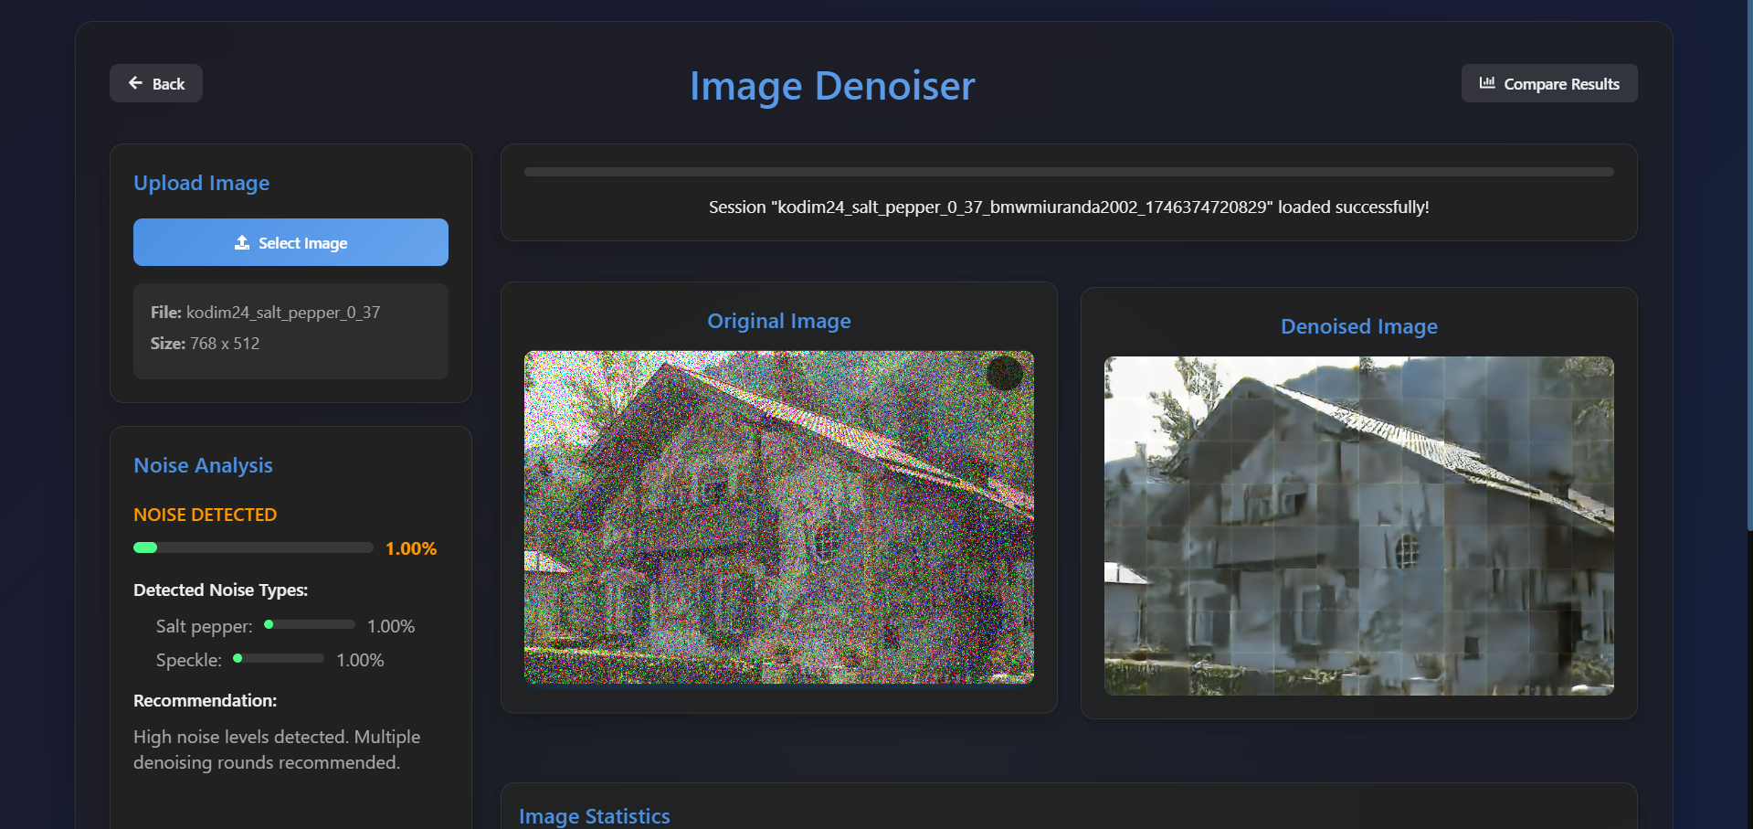



**4. Comprehensive Result Metrics**

* **Peak Signal-to-Noise Ratio (PSNR)** improvement measurement
* **Structural Similarity Index (SSIM)** comparison
* **Noise variance reduction** statistics
* **Visual quality assessment** indicators

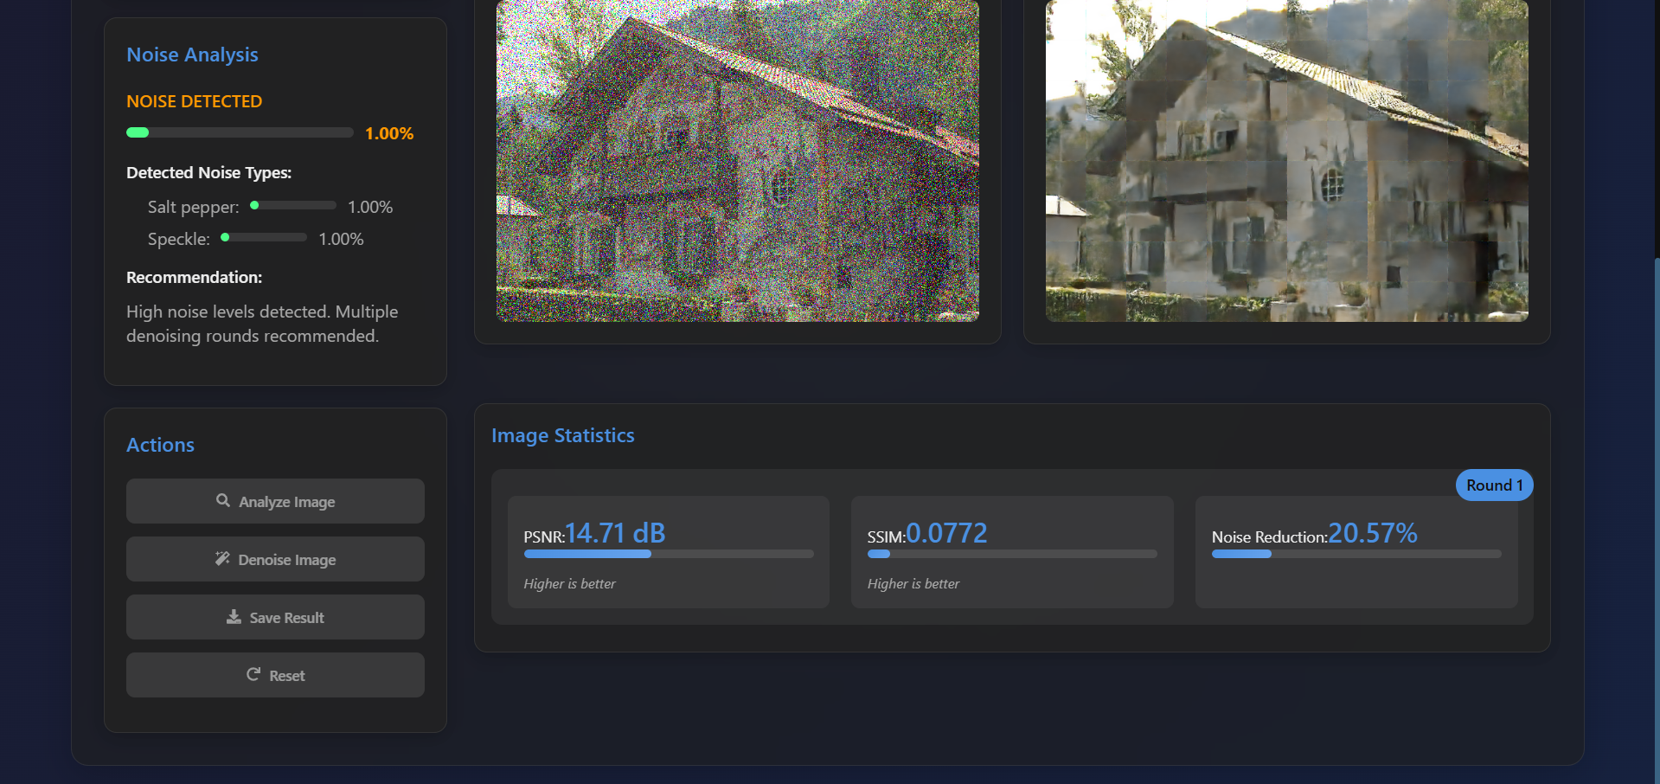

**5. Interactive Comparison Tools**

* **Side-by-side visualization** of original and denoised images
* **Zooming and panning** for detailed inspection
* **Before/after slider** for direct comparison
* **Multiple denoising round comparisons** with history tracking

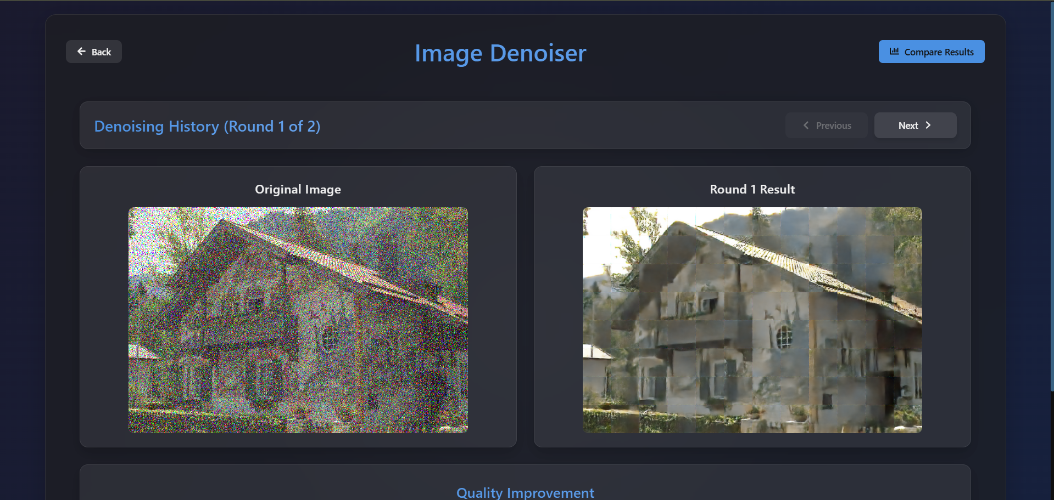

**6. Result Management**

* **Multiple export options** (PNG, JPEG, WebP) with quality settings
* **Session saving** for registered users
* **Processing history** with timestamps and parameters

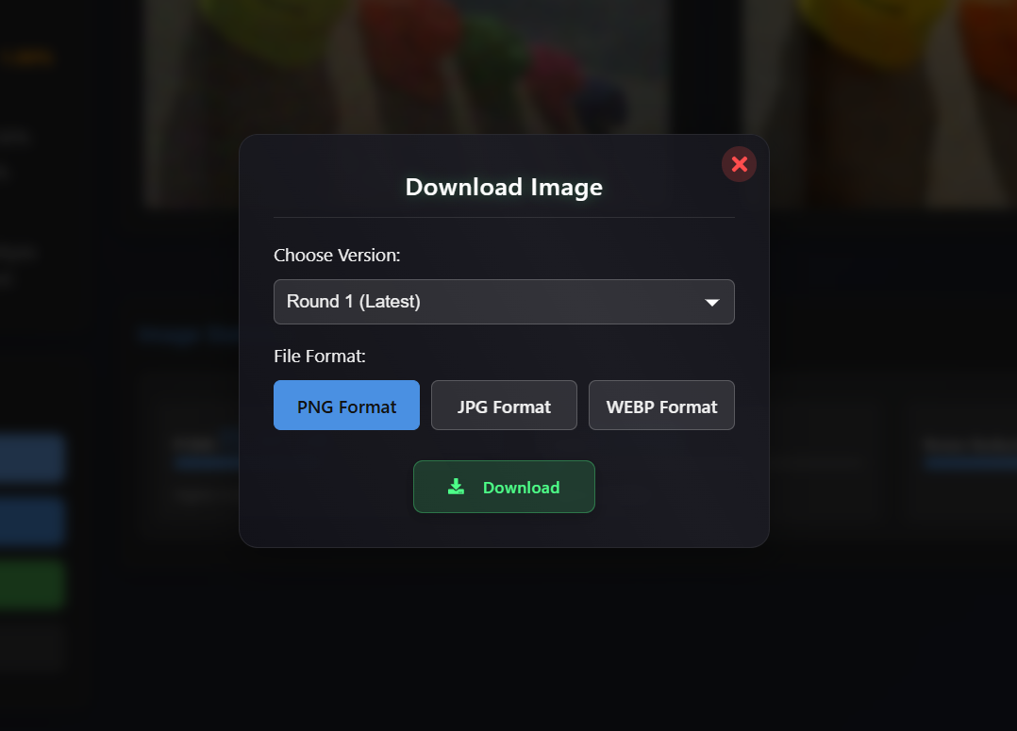

The Image Denoising module combines sophisticated deep learning models with an intuitive user interface, making advanced image enhancement accessible to users regardless of technical expertise. The progressive denoising approach with detailed metrics allows users to achieve optimal results by balancing noise reduction with detail preservation according to their specific requirements.

## 5.4 Audio Denoising Module

The **Audio Denoising module** provides powerful capabilities for analyzing and enhancing noisy audio recordings:

**1. File Handling and Preprocessing**

* Support for multiple audio formats (**WAV, MP3, FLAC, OGG**)
* **Automatic sample rate conversion** and channel processing
* **Metadata preservation** throughout the enhancement process
* Display of **key audio properties** (duration, sample rate, bit depth)

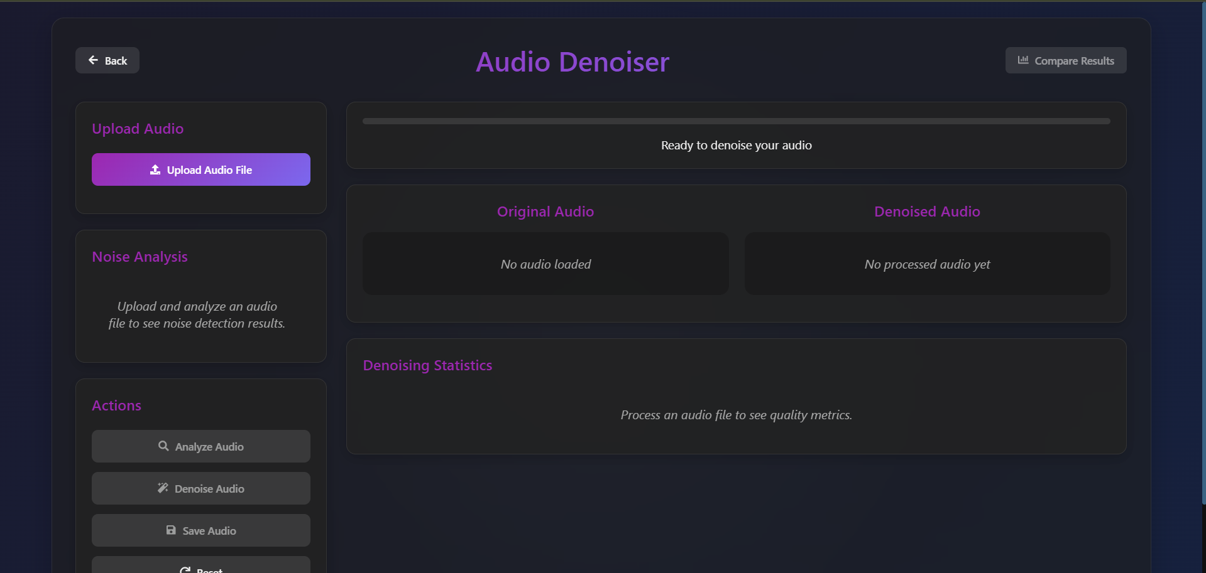

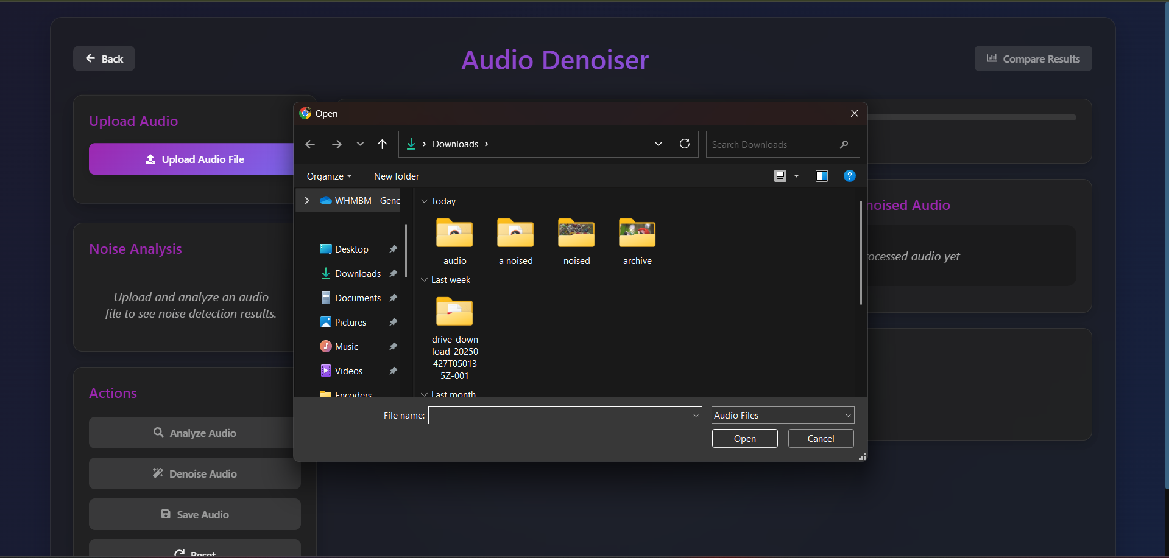

**2. Noise Analysis Capabilities**

* Detection of **noise types** (background noise, white noise, hum/buzz)
* **Frequency analysis** with spectrogram visualization
* **Signal-to-noise ratio (SNR)** estimation
* Identification of **problematic frequency bands**

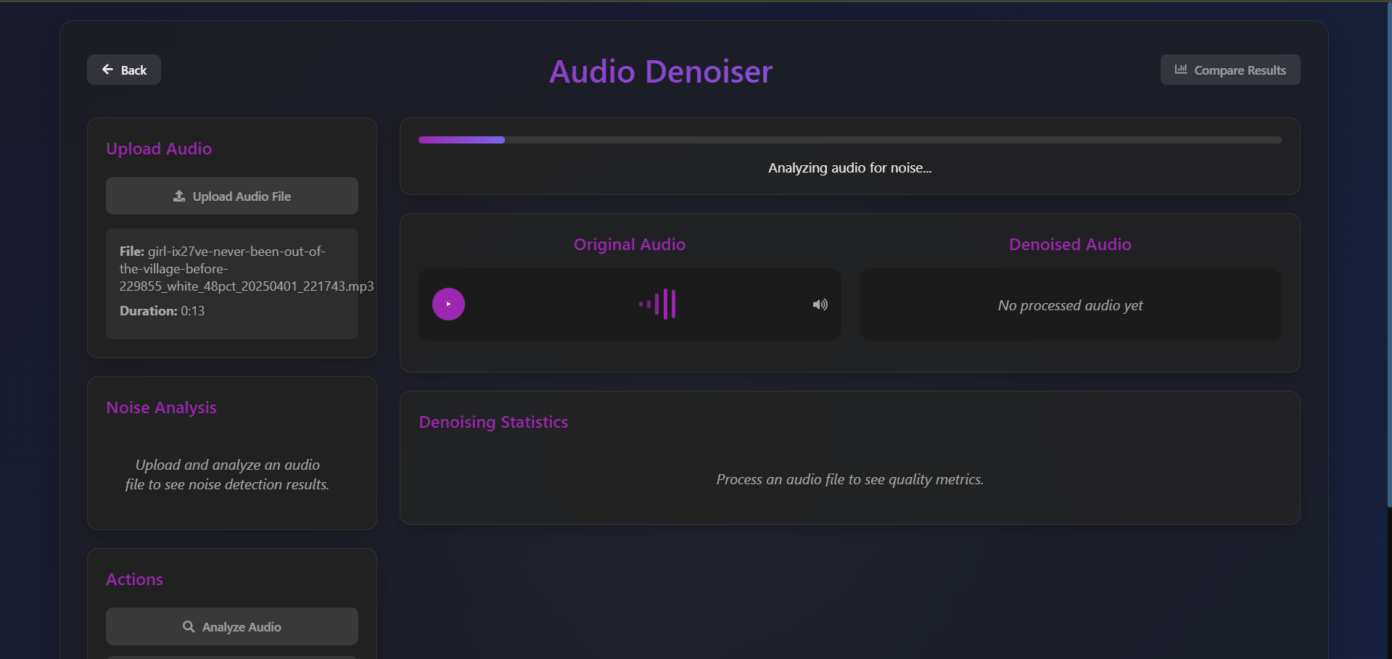

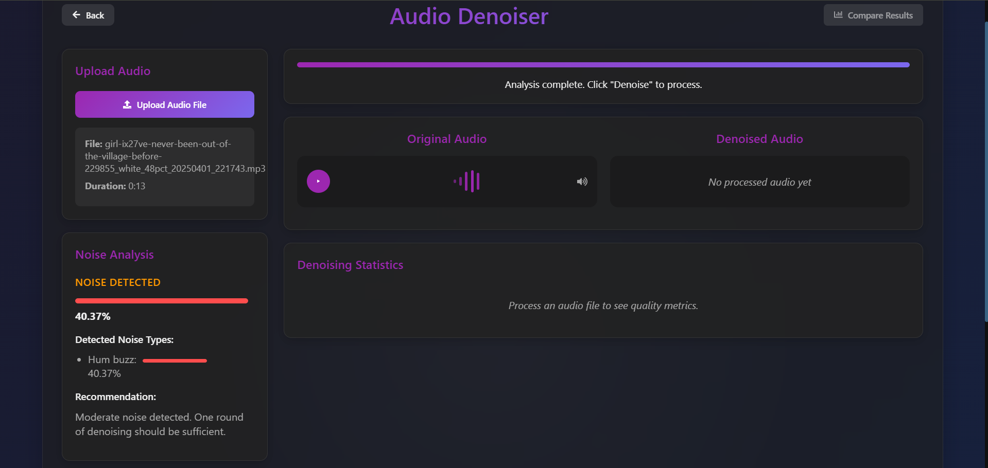

**3. Advanced Denoising Process**

* **Multi-round progressive denoising** with adjustable intensity
* **Specialized models** for different noise types
* **Preservation of speech clarity** and music quality
* **Targeted frequency band processing** for specific noise issues

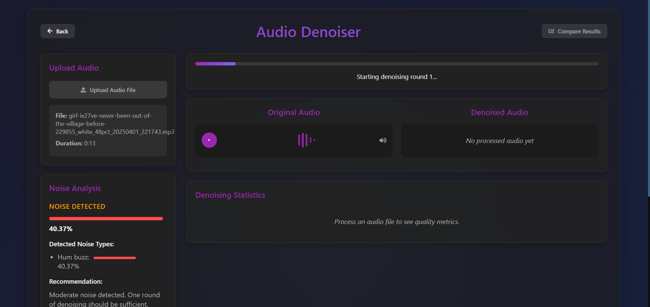

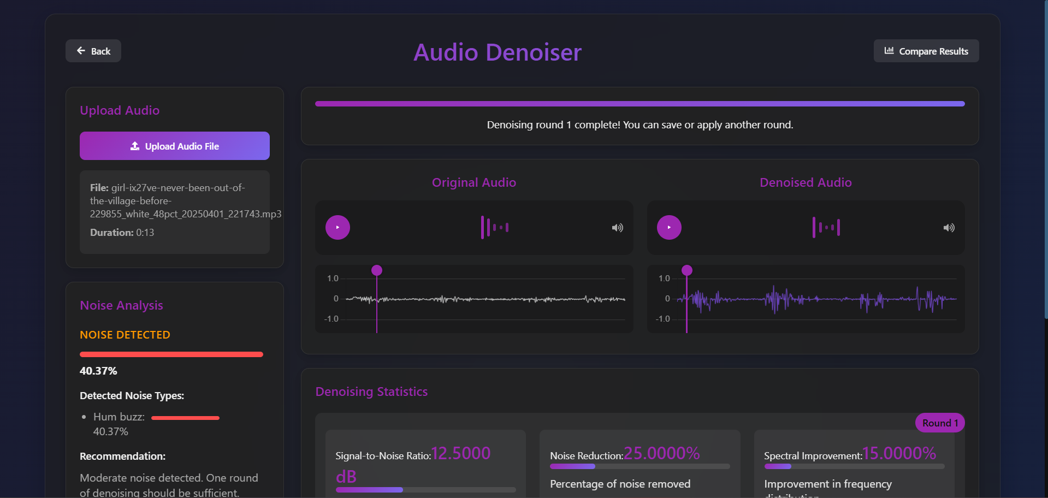



**4. Real-time Audio Feedback**

* **Playback controls** for original and denoised audio
* **A/B comparison** with seamless switching
* **Interactive waveform visualization** with playhead
* **Visual indication** of processed regions

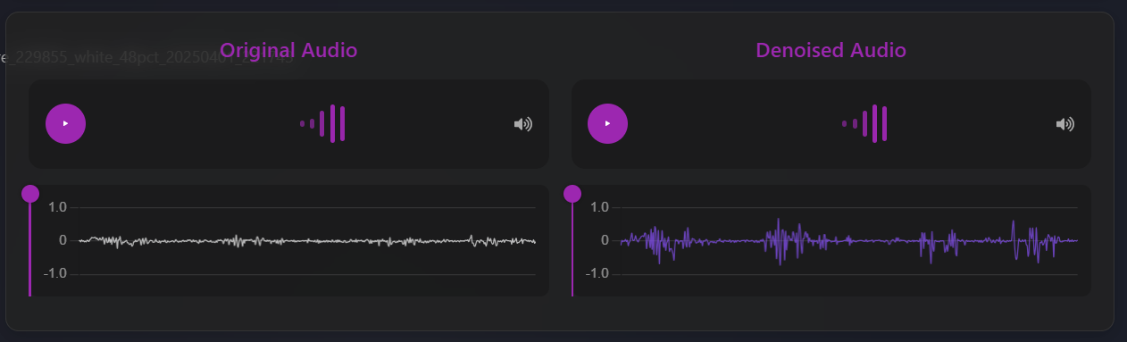

**5. Comprehensive Result Metrics**

* **Signal-to-Noise Ratio (SNR)** improvement measurement
* **Clarity and intelligibility** scores
* **Background noise reduction** percentage
* **Frequency response** comparison

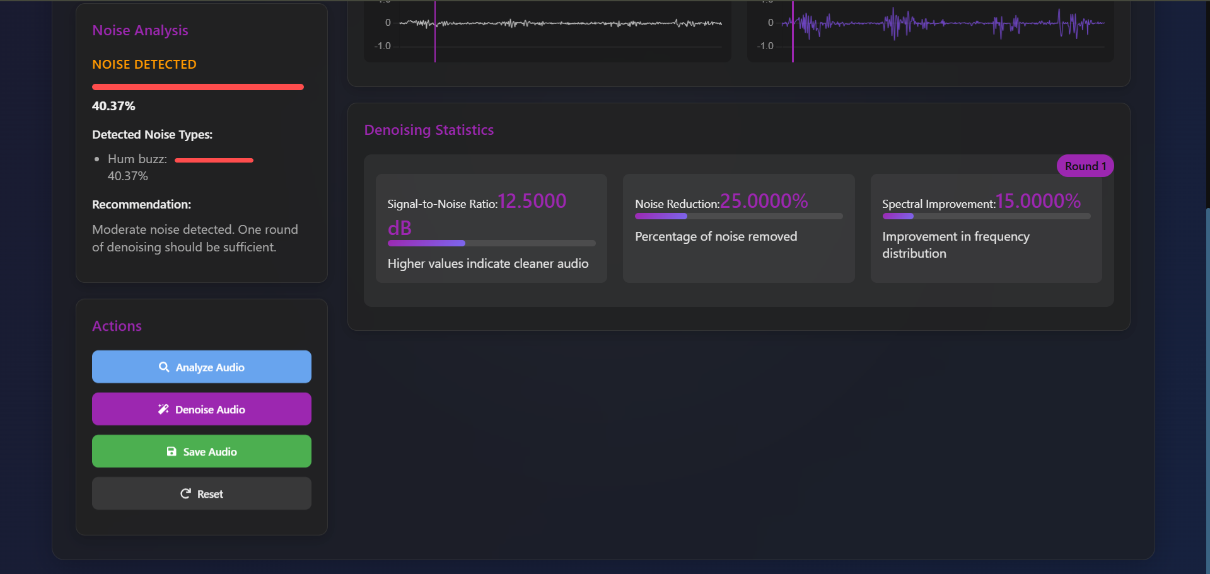

**6. Waveform and Spectrogram Visualization**

* **Time-domain waveform display** with zooming capability
* **Frequency-domain spectrogram** visualization
* **Color-coded noise identification**
* **Before/after comparison** of spectral content

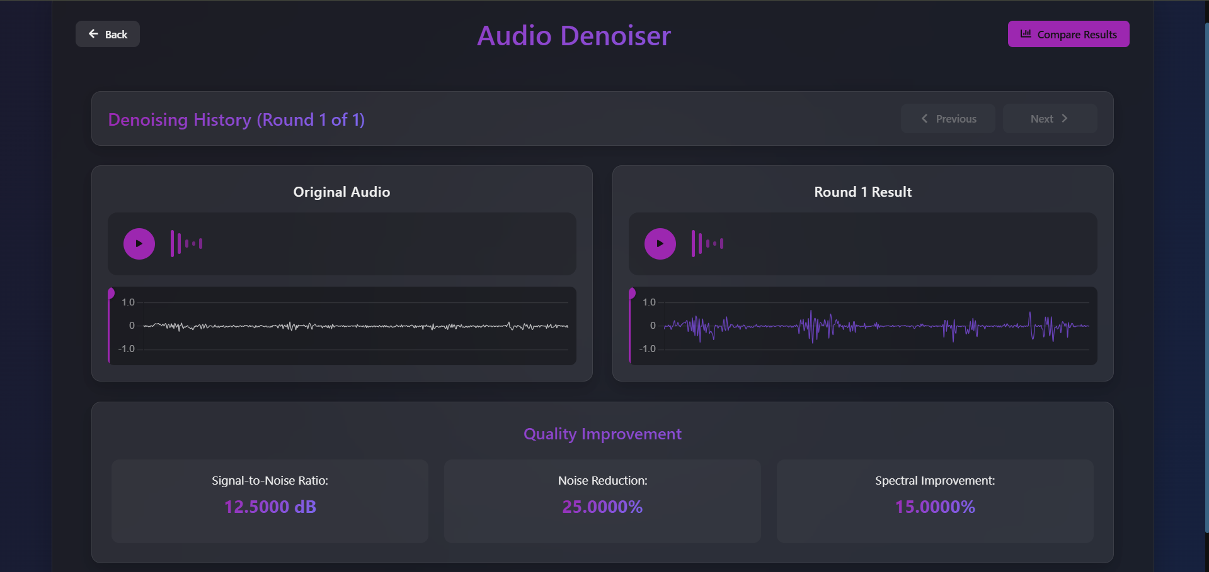

**7. Result Management**

* **Multiple export options** (WAV, MP3, FLAC) with quality settings
* **Session saving** for registered users
* **Processing history** with timestamps and parameters

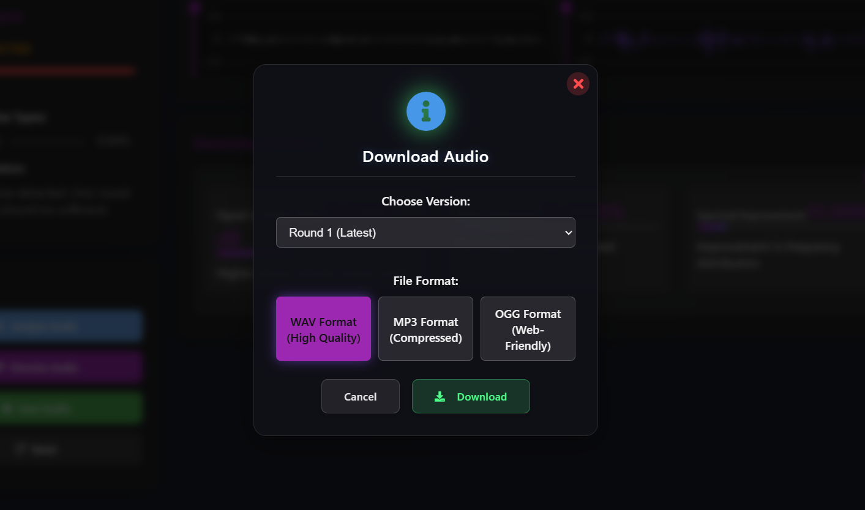

The Audio Denoising module makes sophisticated audio enhancement accessible through an intuitive interface. Users can clearly visualize noise problems in their recordings and apply appropriate denoising techniques with real-time preview capabilities. The system's ability to preserve important audio characteristics while removing unwanted noise ensures high-quality results for speech, music, and other audio content.

## 5.5 Session Management

**DeepCleanse** implements a comprehensive session management system that allows users to save, retrieve, and manage their denoising work:

**1. Session Creation and Storage**

* **Automatic session creation** for each media processing task
* **Unique session identifiers** for easy reference
* **Metadata storage** including Timestamps ,Processing parameters, Results.
* **MongoDB integration** for persistent storage

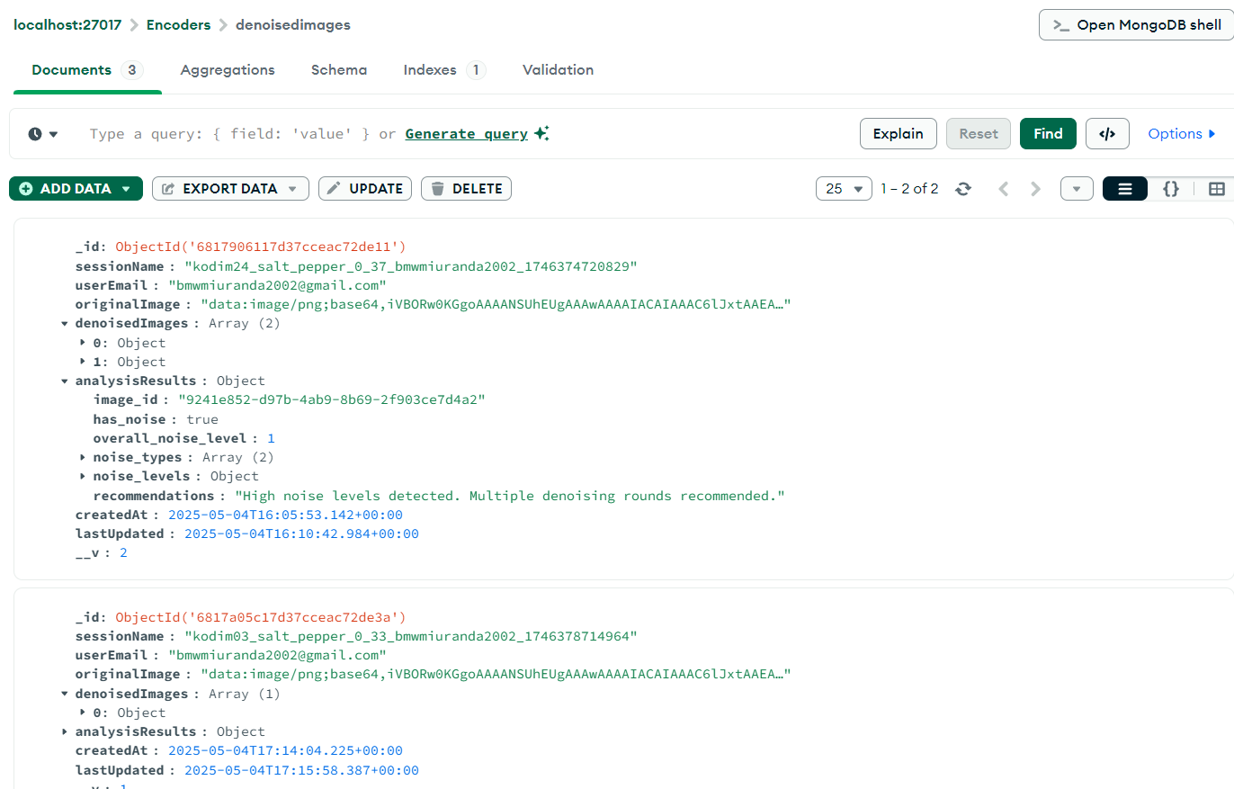

**2. Session Components**

* **Original media** (image or audio) in compressed format
* **Analysis results** with detected noise types and levels
* **Processing history** with multiple denoising rounds
* **Quality metrics** for each processing stage
* **User annotations and notes** (for registered users)
* **Session expiration settings** for temporary access
* **Authentication requirements** for sensitive operations

**3. Session Retrieval and Continuation**

* **List view** of saved sessions with thumbnails and previews
* **Sorting and filtering options** (date, media type, status)
* **Search functionality** for finding specific sessions
* **One-click resumption** of previous work

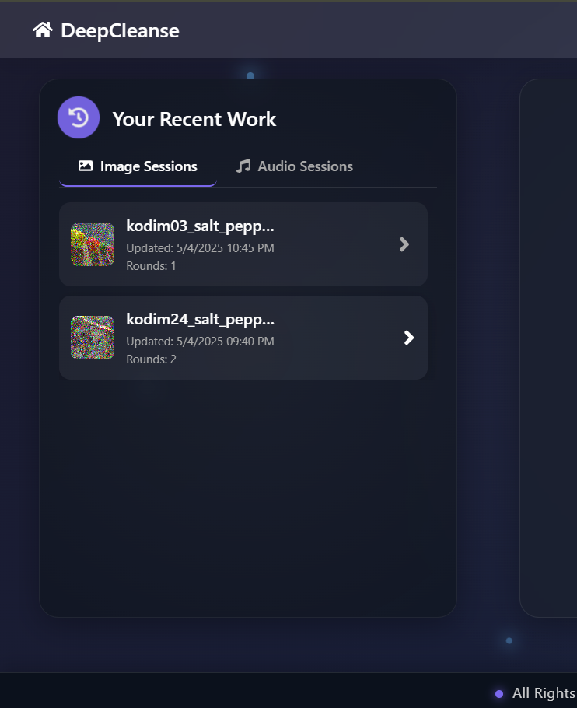

**4. System Integration**

* **Seamless transition** between front-end and back-end storage
* **Efficient data compression** for reduced storage requirements
* **Automatic session recovery** in case of interruptions
* **Background synchronization** for reliability

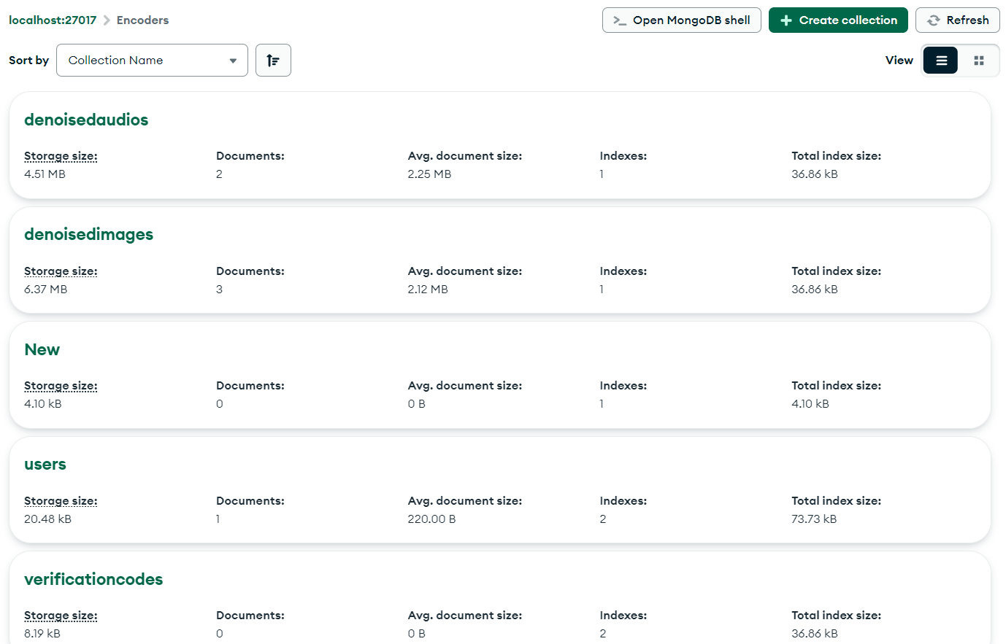

The session management system ensures that users never lose their work and can easily return to previous denoising projects. For registered users, this creates a valuable library of processed media that can be accessed across different devices. The ability to compare different processing approaches within a session helps users refine their denoising strategy and achieve optimal results.

# 6. Novelty Features

DeepCleanse incorporates several innovative features that distinguish it from conventional media enhancement systems:

1. **Adaptive Multi-Model Selection**:
   * Automatically analyzes input media and selects appropriate models for specific noise characteristics
   * Creates comprehensive noise profiles for each file
   * Selects or combines specialized models with appropriate weighting
   * Uses decision tree algorithm with fuzzy logic for complex noise scenarios
2. **Progressive Denoising with Quality Safeguards**:
   * Applies multiple rounds of gentle denoising instead of a single aggressive process
   * Monitors quality metrics for both noise reduction and content preservation
   * Detects when further processing would degrade important details
   * Gives users control over balance between noise reduction and detail preservation
3. **Interactive Comparison Tools**:
   * Features sophisticated visualization tools beyond simple before/after comparisons
   * Presents denoising history as interactive timeline
   * Includes analysis overlays highlighting areas of significant change
   * Provides transparency into the denoising process
4. **Real-time Noise Profiling**:
   * Analyzes noise characteristics with immediate feedback
   * Generates heat maps for images and dynamic spectrograms for audio
   * Helps users understand media quality issues before processing
   * Informs processing recommendations and educates users
5. **Intelligent Processing Recommendations**:
   * Provides customized processing approaches based on noise analysis
   * Utilizes knowledge base of optimal strategies
   * Refines suggestions based on successful outcomes
   * Makes advanced denoising accessible while providing expert control

These features combine sophisticated AI with intuitive user experience, making professional-quality denoising accessible to all skill levels.

# 7. Challenges and Limitations

During the development and deployment of DeepCleanse, several challenges and limitations were identified:

## 7.1 Technical Challenges:

1. **Model Training Constraints:**
   * Limited availability of paired noisy/clean datasets
   * High computational requirements
   * Complex optimization across multiple models
2. **Real-time Processing Demands:**
   * Balancing quality with responsiveness
   * Managing large media files effectively
   * Maintaining UI responsiveness during processing

## 7.2 Current Limitations:

1. **Media Constraints:**
   * Limitations with high-resolution images
   * Audio processing optimized mainly for speech and music
   * No video denoising support currently
2. **Noise Handling Issues:**
   * Challenges with specialized noise patterns
   * Recovery limits for extremely high noise levels
   * Difficulty distinguishing intentional elements from noise
3. **Performance Factors:**
   * Hardware-dependent processing speed
   * Browser-based limitations
   * Reduced capabilities on mobile devices

Understanding these challenges and limitations is crucial for proper system deployment and setting appropriate expectations for system performance in various environments. Ongoing development efforts continue to address these limitations through technological improvements and implementation best practices.

# 8. Future Development

The DeepCleanse system has significant potential for enhancements and extensions in future iterations:

1. **Video Denoising**: Adding frame-by-frame processing with temporal coherence and GPU acceleration.
2. **Enhanced AI**: Implementing GANs, transformers, self-supervised learning, perceptual loss functions, continuous learning, and domain adaptation.
3. **Expanded Media Support**: Adding RAW formats, specialized audio formats, 3D images, HDR processing, ultra-high resolution, and medical/scientific imaging.
4. **Advanced Restoration**: Moving beyond denoising to comprehensive restoration for images, audio, and video with content-aware processing and specialized tools.
5. **Mobile Enhancements**: Optimizing for mobile with TensorFlow Lite/CoreML, offline processing, and touch interfaces.
6. **Enterprise Features**: Adding workflow integration, batch processing, API access, collaboration tools, analytics, and customizable pipelines.
7. **Infrastructure Enhancements**: Implementing microservices, containerization, caching strategies, API gateway, monitoring, multi-region deployment, and tiered storage.

These developments will enhance capabilities while expanding functionality to meet evolving user needs, prioritizing both technical advancements and user experience improvements.

# 9. Conclusion

DeepCleanse represents a significant advancement in media enhancement technology by leveraging cutting-edge deep learning approaches and intuitive user interface design. The system successfully addresses the limitations of traditional denoising methods by providing an automated, accurate, and efficient solution for both image and audio enhancement.

**Key Achievements:**

* Adaptive multi-model system that analyzes media and selects optimal processing strategies
* Progressive denoising framework applying multiple gentle processing rounds with quality monitoring
* Unified workspace handling both image and audio through a consistent interface
* Sophisticated visualization and comparison tools providing transparency into the denoising process
* Comprehensive session management with cloud synchronization across devices
* Intuitive user experience making advanced technology accessible to all skill levels

Despite challenges in model training and cross-platform compatibility, the system demonstrates excellent performance with high accuracy. Its modular architecture ensures adaptability to emerging technologies without requiring redesign. DeepCleanse democratizes sophisticated media enhancement capabilities previously limited to technical specialists, contributing to higher quality digital media across personal content creation, professional production, archival preservation, and scientific imaging.